High Level Design (HLD)

Customer Identity Access Management (CIAM), Core platform implementation design.
October 2026

Contents
Contents 2
Tables 5
Figures 7
1 How to Use This Document 8
1.1 Architecture Lifecycle 8
1.2 Architecture Information Ownership 8
1.3 Working Principle 9
1.4 Relationship to Other Artefacts 9
1.5 Artefact-Specific Guidance 9
1.6 Key Principle 9
2 Logical Architecture 10
2.1 Logical Architecture Overview 10
2.2 Logical Architecture Principles and Standards 10
2.3 Logical Architecture Components 11
2.4 Logical Architecture Interactions and Flows 12
2.5 Logical Architecture Key Design Considerations 13
2.6 Logical Architecture Checklist 13
3 Application Architecture 15
3.1 Application Architecture Overview 15
3.2 Application Architecture Principles and Standards 15
3.3 Application Architecture Components 16
3.4 Application Architecture Interactions and Flows 17
3.5 Application Architecture Key Design Considerations 18
3.6 Application Architecture Checklist 19
4 Integration Architecture 20
4.1 Integration Architecture Overview 20
4.2 Integration Architecture Principles and Standards 20
4.3 Integration Architecture Components 21
4.4 Integration Architecture Interactions and Flows 22
4.5 Integration Architecture Key Design Considerations 23
4.6 Integration Architecture Checklist 24
5 Data Architecture 25
5.1 Data Architecture Overview 25
5.2 Data Architecture Principles and Standards 25
5.3 Data Architecture Components 26
5.4 Data Architecture Interactions and Flows 27
5.5 Data Architecture Key Design Considerations 28
5.6 Data Architecture Checklist 28
6 Information Security Architecture 30
6.1 Information Security Overview 30
6.2 Information Security Principles and Standards 30
6.3 Information Security Classification and Handling 31
6.4 Information Security Controls 32
6.5 Threats, Risks and Mitigations 32
6.6 Security Compliance Requirements 33
6.7 Information Security Checklist 34
7 Security Architecture 35
7.1 Security Architecture Overview 35
7.2 Security Architecture Principles and Standards 35
7.3 Security Architecture Components 36
7.4 Security Architecture Interactions and Flows 37
7.5 Security Architecture Key Design Considerations 38
7.6 Security Architecture Checklist 38
8 Infrastructure Architecture 40
8.1 Infrastructure Architecture Overview 40
8.2 Infrastructure Architecture Principles and Standards 40
8.3 Infrastructure Architecture Components 41
8.4 Infrastructure Architecture Interactions and Flows 42
8.5 Infrastructure Architecture Key Design Considerations 43
8.6 Infrastructure Architecture Checklist 43
9 Environment Architecture 45
9.1 Environment Architecture Overview 45
9.2 Environment Architecture Principles and Standards 45
9.3 Environment Architecture Components 46
9.4 Environment Architecture Interactions and Flows 47
9.5 Environment Architecture Key Design Considerations 49
9.6 Environment Architecture Checklist 50
10 Non-Functional Design 51
10.1 Availability 51
10.2 Performance 51
10.3 Scalability 52
10.4 Resilience and Recoverability 53
10.5 Operability and Supportability 54
10.6 Non-Functional Design Checklist 55
11 RAID Assessment 56
11.1 Architecture Decisions 56
11.2 Risks & Mitigation Actions 60
11.3 Assumptions & Constraints 62
11.4 Issues & Open Questions 64
11.5 Dependencies 65
12 Document Control 67
12.1 Document Information 67
12.2 Revision History 67
12.3 Review & Approval 68
12.4 References 68
12.5 Architecture Repository References 68
12.6 Document Submission Status 69
12.7 Document Approval 69
13 Architecture Reference Material 70
13.1 Glossary of Acronyms & Terms 70
13.2 Architecture Model & Diagram Definitions 70
14 Appendix 71

Tables
Table 1 - Architecture Lifecycle 8
Table 2 - Architecture Information Ownership 9
Table 3 - Logical Architecture Principles and Standards 11
Table 4 - Logical Architecture Components 12
Table 5 - Logical Architecture Interactions and Flows 12
Table 6 - Logical Architecture Key Design Considerations 13
Table 7 - Application Architecture Principles and Standards 16
Table 8 - Application Architecture Components 17
Table 9 - Application Architecture Interactions and Flows 18
Table 10 - Application Architecture Key Design Considerations 18
Table 11 - Integration Architecture Principles and Standards 21
Table 12 - Integration Architecture Components 22
Table 13 - Integration Architecture Interactions and Flows 23
Table 14 - Integration Architecture Key Design Considerations 23
Table 15 - Data Architecture Principles and Standards 26
Table 16 - Data Architecture Components 27
Table 17 - Data Architecture Interactions and Flows 27
Table 18 - Data Architecture Key Design Considerations 28
Table 19 - Security Principles 31
Table 20 - Information Classification Levels 31
Table 21 - Information Security Controls 32
Table 22 - Security Risks and Mitigations 33
Table 23 - Security Compliance Requirements 33
Table 24 - Security Architecture Principles and Standards 36
Table 25 - Security Architecture Components 37
Table 26 - Security Architecture Interactions and Flows 38
Table 27 - Security Architecture Key Design Considerations 38
Table 28 - Infrastructure Architecture Principles and Standards 41
Table 29 - Infrastructure Architecture Components 42
Table 30 - Infrastructure Architecture Interactions and Flows 43
Table 31 - Infrastructure Architecture Design Considerations 43
Table 32 - Environment Architecture Principles and Standards 46
Table 33 - Environment Architecture Components 47
Table 34 - Environment Architecture Interactions and Flows 49
Table 35 - Environment Architecture Key Design Considerations 49
Table 36 - Availability Requirements 51
Table 37 - Performance Requirements 52
Table 38 - Scalability Requirements 53
Table 39 - Resilience and Recoverability Requirements 54
Table 40 - Operability and Supportability Requirements 54
Table 21 - Architecture Decision Register 57
Table 22 - Decision Impacts and Trade-Offs 57
Table 23 - Decision Relationships and Dependencies 57
Table 24 - Project Risk Register and Mitigation Plan 61
Table 25 - Project Assumptions Register 63
Table 26 - Project Constraints Register 63
Table 27 - Issues and Open Questions Register 65
Table 28 - Capability Ownership Matrix 66
Table 29 - Project Dependency Register 66
Table 50 - Document Status Overview 67
Table 51 - Document Revision History 67
Table 52 - Document Review & Endorsement Status 68
Table 53 - References 68
Table 54 - Architecture Repository References 68
Table 55 – Document Submission Status – Document Name 69
Table 56 – Document Approval – Document Name 69

Figures
Figure 1 - Logical Architecture Diagram 10
Figure 2 - Logical Component Model 11
Figure 3 - Logical Flow Diagram 12
Figure 4 - Application Architecture Diagram 15
Figure 5 - Application Interaction Diagram 16
Figure 6 - Application Communication Diagram 17
Figure 7 - Integration Architecture Diagram 20
Figure 8 - Interface Topology 21
Figure 9 - Sequence / Integration Flow Diagrams 22
Figure 10 - Data Architecture Diagram 25
Figure 11 - Data Store Model 26
Figure 12 - Information Flow Diagram 27
Figure 13 - Information Security Architecture Overview 30
Figure 15 - Security Architecture Diagram 35
Figure 16 - Security Controls Model 36
Figure 17 - Authentication / Authorisation Flow 37
Figure 18 - Infrastructure Diagram 40
Figure 19 - Hosting Architecture 41
Figure 20 - Connectivity Diagram 42
Figure 21 - Environment Topology Diagram 45
Figure 22 - Environment Promotion Flow 47
Figure 23 - NFR Matrix 51

- How to Use This Document
Purpose: This document forms part of the Architecture Lifecycle and should be read together with preceding architecture artefacts. The architecture is progressively developed across multiple stages, with each artefact building upon information previously approved.

The architecture is intended to be cumulative rather than repetitive. Information documented and approved in earlier artefacts remains authoritative and should not be duplicated unless explicitly required for context.

CAD → SOD → HLD → DD is a progressive accumulation of architecture knowledge.

  - Architecture Lifecycle
The architecture is developed through the following stages:
Artefact | Purpose
Concept Architecture Document (CAD) | Defines business context, drivers, objectives, requirements, principles, target state and architecture direction.
Solution Options Document (SOD) | Defines solution scope, evaluates options and identifies the preferred solution approach.
High Level Design (HLD) | Defines the logical architecture and technology design required to implement the approved solution.
Detailed Design (DD) | Defines implementation-level specifications needed to build, configure, integrate and operate the solution.
Table 1 - Architecture Lifecycle
Each stage inherits and builds upon approved content from previous stages.

  - Architecture Information Ownership
Each architecture topic has a single authoritative location within the architecture lifecycle.
Once approved, information should not be recreated or maintained in multiple documents.
Information Type | Authoritative Artefact
Business Context | Conceptual Architecture Document (CAD)
Requirements | Conceptual Architecture Document (CAD)
Architecture Drivers & Principles | Conceptual Architecture Document (CAD)
Target State Vision | Conceptual Architecture Document (CAD)
Architecture Alignment & Impacts | Conceptual Architecture Document (CAD)
Solution Definition | Solution Overview Document (SOD)
Options Assessment | Solution Overview Document (SOD)
Architecture Decisions | Solution Overview Document (SOD)
High-Level Architecture Design | High Level Design (HLD)
Detailed Design Specifications | Detailed Design (DD)
Compliance & Assurance | Design Assurance (DA)
Table 2 - Architecture Information Ownership
  - Working Principle
When developing this document:
- Reference approved content from previous artefacts where appropriate.
- Do not duplicate information solely to make the document standalone.
- Focus only on the architectural concerns assigned to this artefact.
- Maintain traceability to decisions, requirements and previous approvals.
- Use references to prior documents instead of reproducing content.
- Record only new information introduced at this lifecycle stage.

  - Relationship to Other Artefacts
This document should be read in conjunction with:
- Approved predecessor architecture artefacts.
- Relevant Architecture Decision Records (ADRs).
- Enterprise Reference Architectures.
- Applicable standards, policies and governance requirements.
Where conflicts exist, the most recently approved authoritative artefact takes precedence.

  - Artefact-Specific Guidance
Conceptual Architecture Document (CAD): This document establishes the architecture foundation for the initiative. It defines the business context, requirements, target state, principles, risks and architecture direction that all subsequent architecture activities must align with.

Solution Overview Document (SOD): This document builds upon the approved CAD and defines the solution approach, option assessment, key decisions and preferred architecture direction. Business context and requirements remain authoritative in the CAD.

High Level Design (HLD): This document builds upon the approved CAD and SOD and defines the logical architecture, architecture domains and high-level technology design. Decisions, requirements and solution direction remain authoritative in preceding artefacts.

Detailed Design (DD): This document builds upon the approved CAD, SOD and HLD and provides implementation-level design specifications required for build, deployment, integration and operational readiness.

  - Key Principle
This document is part of a cumulative architecture lifecycle. It is not intended to be a standalone description of the solution. Approved information remains authoritative in the artefact where it was originally defined and should be referenced rather than duplicated.
- Business context
WorkCover Queensland (WCQ) is undertaking a multi‑year transformation to modernise its digital ecosystem and improve how external customers (Injured workers, Related parties, Employer, Treating Providers, etc) securely access services. The current environment relies on legacy, bespoke identity capabilities embedded within existing applications, resulting in inconsistent user experiences, limited scalability, fragmented identity data, and increased operational overhead. These constraints make it difficult to deliver secure, seamless, and consistent digital services across customer channels and user cohorts.
At present, identity management, authentication, and access control are tightly coupled to CPIS causing challenges in introducing modern secure authentication capabilities, increasing fraud risk and limiting the organisation’s ability to enhance and secure digital portals.
To address these challenges, WCQ is introducing a centralised Customer Identity and Access Management (CIAM) platform as a foundational enterprise capability. The CIAM solution will provide a unified control plane for managing customer identities, authentication, and authorisation across all digital services. It enables secure, standards-based access using OAuth2, OpenID Connect, and federation, supporting seamless single sign-on (SSO), adaptive authentication, and integration with trusted identity providers. The selected vendor SaaS solution is Auth0 (Auth Zero).
The solution delivers the following key business outcomes:
- Improved customer experience through seamless, low-friction authentication journeys, including SSO and federated identity options
- Stronger security and risk management through consistent enforcement of authentication policies, identity proofing (e.g. ConnectID), and adaptive, risk-based controls
- Reduced fraud and improved trust by ensuring that digital identities are reliably linked to verified individuals and customer records
- Operational efficiency and scalability by centralising identity lifecycle management and reducing duplication across applications
- Consistent access control across portals, mobile applications, APIs, and third-party services
The CIAM capability underpins critical enterprise platforms including Digital Experience (portals and mobile applications), API Gateway, Enterprise Integration services, Customer Data platforms (e.g. CRM and future core systems), and external identity ecosystems such as ConnectID and government identity services. It acts as the central identity authority while integrating with enterprise systems for customer data, communication services, and security monitoring (e.g. Microsoft Sentinel).
The solution aligns with WCQ’s enterprise architecture principles by adopting a SaaS-first approach, leveraging industry standards, and embedding security and privacy by design. It also supports future capabilities such as fine-grained authorisation, fraud monitoring integration, and advanced identity governance as the broader 2030 transformation program evolves.
- Logical Architecture
Purpose: Describes the logical structure of the solution independent of specific technologies, products or implementation details. This section defines the major functional building blocks, their responsibilities and interactions, providing a technology-agnostic view of how the solution delivers business capabilities and requirements.
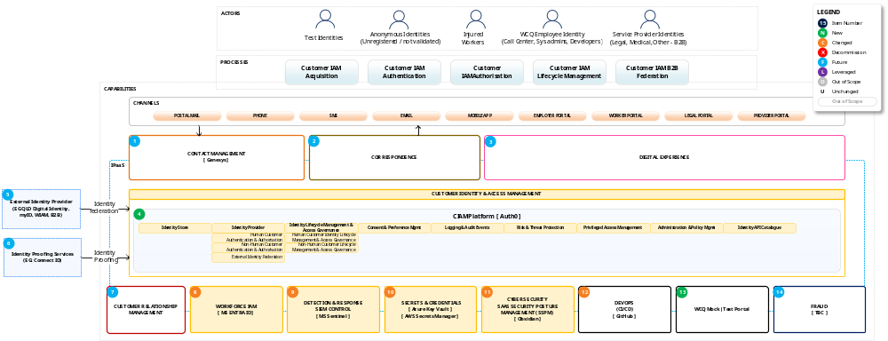
Figure 1 - Logical Architecture Diagram
  - Logical Architecture Overview
The initial logical architecture defines the base CIAM (Auth0) SaaS deployment, hosted by AWS which serves as the strategic Customer Identity and Access Management capability. CIAM will manage digital identities, user profiles, credentials, configurations, identity centric user experience (UX) screens (registration, authentication and profile management). CIAM provides dedicated Authentication and Management API catalogue and supports business logic to securely connect digital customer portals, external identity providers and business to business (B2B) solutions.
  - Architecture Scope & Boundaries
The scope of the logical architecture encompasses the initial deployment of the Auth0 SaaS platform along with six platform environments with connectivity to core WCQ systems as define in the logical architecture diagram above.
The deployment will be iteratively expanded across future project and design releases, with initial key components to include SIEM and Observability platform connectivity, establishment of a CI/CD pipeline and the deployment of a non-production Mock / Test Portal (for technical showcase and testing purposes) hosed within the WCQ Azure cloud.
Solution Layers & Major Functional Groupings
- The end user Context comprises “test identities” accessing authentication services through a development WCQ Mock Web Portal.
- WCQ Business applications are out of scope for the initial implementation.
- Auth0 SaaS platform: Central Auth0 Tenant hosting CIAM capabilities.
- Federation & External Providers: Interfaces with external identity providers such as the Mock test portal to enable federated authentication / SSO. Scope excludes External Identity Providers such and QLD Digital Identity, MyID and Identity proofing services such as ConnectID.
- Operational core components include:
  - Workforce identity federation (WCQ Azure ID) for platform administration and initial configuration.
  - Connectivity of required environments to the WCQ SEIM – Microsoft Sentinel.
  - Configuration of the WCQ secret and credential management service for use by the CIAM CI/CD pipelines.
  - Configure Obsidian SSPM observability tool as per WCQ Cyber Security requirements.
  - WCQ GitHub CI/CD pipeline configuration to six Auth0 environments.
  - Hosting (WCQ Azure) and integration to a mock test portal for technical testing and showcase purposes.
- Future, proposed integrations include:
  - Genesys for assisted services (Call Centre) identity attribute management (change of mobile number or email address), caller verification and identification, credential or registration assistance.
  - WCQ Correspondence platform – integration required with Auth0 for multi factor authentication (delivery of SMS and email based one-time pins (OTPs))
  - Integration to WCQ Digital experience capability to support authentication requirements of the various business portals.
  - External Identity providers (Queensland Digital ID, MyID, etc.) and Identity Proofing services (ConnectID)
  - Customer relationship Management platform – The specific integration is to be defined on a cohort by cohort basis and is out of scope for the core Auth0 deployment. Identity data in Auth0 is a subset of a CRM data record for an individual. Auth0 and CRM will need to integrate in the future to ensure data currency across the two platforms ensuring a high level of data quality in “customer systems’ at WCQ.
  - Fraud Platform integration is currently out of scope for the core platform integration. In the future when Auth0 is integrated with a business portal, Auth0 can send identity-based risk signals to the WCQ fraud platform, either via the SIEM or directly.
Relationship to Business Capabilities
This architecture directly enables the SaaS Auth0 platform, associated core WCQ environments and real-time security event audit auditing as well as configuration management.

  - Logical Architecture Principles and Standards
Principle | Application
Iterative delivery | To establish a foundational CIAM framework designed for progressive expansion in future phases, the Auth0 tenant serves as the primary operational engine. Meanwhile, auxiliary elements, specifically the mock Web Portal are initially implemented as mock components for testing purposes only.
Separation of Concerns | External identity management and authentication functions are decoupled from production portals, and downstream messaging channels (e.g. email, SMS).
Modularity | Logical capabilities are organised into discrete functional modules within the Auth0 tenant, including Authentication, Management API, User Profiles and Credentials, Custom Business Logic and related configurations.
Reuse Before Build | Leverages native Auth0 SaaS capabilities and existing WCQ enterprise infrastructure (e.g., Azure AD, Sentinel, Datadog) rather than custom-built alternatives.
Loose Coupling | Functional domains interact through defined interfaces leveraging standards based, open protocols (OAuth 2.0, OIDC, SAML 2.0, REST APIs) to minimize inter-system dependencies.
Data minimisation | Future state production environment:  Customer PII stored in the Auth0 production tenant will be minimized to just enough PII to allow an external user to authenticate to a WorkCover Queensland business portal.  Future business portal integration projects will define a subset of identity attributes required for each such portal which may differ based on cohort type and business requirements. Additionally, Auth0 profile data (the digital identity)will be stored within the Auth0 identity store and may include opaque immutable identifiers for the end user, eg: GUID, External ID, CRM ID etc.
Table 3 - Logical Architecture Principles and Standards

  - Logical Architecture Components
Identifies the logical components and functional services that make up the solution.
Figure 2 - Logical Component Model

ID | Logical Component | Responsibility
1 | Contact management (Genesis) | Future integration - Customer service identity attribute management, Customer interaction, Customer identification and authentication
2 | Correspondence | Future integration - Manages external communication using various channels such as Postal, email and mobile SMS for One time PIN (OTP) delivery.
3 | WCQ Digital Experience layer | Digital content management, static assets, web services which make up Digital service portals.
4 | CIAM Platform | Auth0 CIAM platform – External individual and business web portal authentication
5 | External Identity Provider | Leverages State and Federal Identity providers for authentication using verifiable credentials
6 | Identity Proofing Services | External identity proofing services such as ConnectID. Verifies a human identity to an authoritative source with fraud mitigation capabilities
7 | WCQ CRM | WCQ authoritative source for identity data for CIAM
8 | Workforce IAM | WCQ Enterprise Directory (EntraID) - WCQ Staff Identity provider for Call centre CIAM operations, Sys Admins & Identity development teams
9 | WCQ Security and Event Management System (SIEM) | WCQ Security and Event Management System. Microsoft Sentinel
10 | Secrets and credentials | WCQ Secrets and credential management
11 | SaaS Security Posture management | Obsidian SaaS security posture management
12 | DevOps CI/CD | WCQ GitHub integration for configuration management
13 | WCQ: Mock | Test Portal | Hosted in QCQ Azure cloud for testing identity services
14 | WCQ Fraud System | Future integration to enable identity centric, digital fraud signals to be forwarded to the WCQ Fraud platform  - Auth0 to forward logs to a fraud management platform  - Fraud platform to ingest logs from another source, i.e. Microsoft Sentinel
Table 4 - Logical Architecture Components

  - Logical Architecture Interactions and Flows
Describes how logical components collaborate to deliver business capabilities and fulfil requirements.

Figure 3 - Logical Flow Diagram
ID | Source Component | Target Component | Interaction
1 | Contact management (Genesis) | CIAM | Future integration - Customer service identity attribute management, Customer interaction, Customer identification and authentication
2 | Correspondence | CIAM  WCQ Cohorts | Future integration - Manages external communication using various channels for multifactor authentication (MFA) such as email and mobile SMS for One time PIN (OTP) delivery.
3 | WCQ Digital Experience layer | CIAM | Future integration - Digital content management, static assets, web services which make up Digital service portals.
4 | CIAM Platform | - Workforce IAM  - WCQ Security and Event Management System (SIEM)  - Secrets and credentials  - SaaS Security Posture management (Obsidian)  - DevOps CI/CD (GitHub)  - WCQ: Mock | Test Portal | Auth0 CIAM platform – Core platform integrations for initial platform deployment project
5 | External Identity Provider | CIAM | Future integration - Leverages State and Federal Identity providers for authentication using verifiable credentials
6 | Identity Proofing Services | CIAM | Future integration - External identity proofing services such as ConnectID. Verifies a human identity to an authoritative source with fraud mitigation capabilities
7 | WCQ CRM | CIAM | Future integration - WCQ authoritative source for identity data for CIAM
8 | Workforce IAM | CIAM | WCQ Enterprise Directory (EntraID) - WCQ Staff Identity provider for Call centre CIAM operations, Sys Admins & Identity development teams
9 | WCQ Security and Event Management System (SIEM) | CIAM | WCQ Security and Event Management System. Microsoft Sentinel
10 | Secrets and credentials | CIAM  GitHub | WCQ Secrets and credential management
11 | SaaS Security Posture management | CIAM | Obsidian SaaS security posture management
12 | DevOps CI/CD | CIAM  GitHub | WCQ GitHub integration for configuration management
13 | WCQ: Mock | Test Portal | CIAM | Hosted in QCQ Azure cloud for testing identity services
14 | WCQ Fraud System | CIAM | Future integration:  - Auth0 to forward logs to a fraud management platform  - Fraud platform to ingest logs from another source, i.e. Microsoft Sentinel
Table 5 - Logical Architecture Interactions and Flows

  - Logical Architecture Key Design Considerations
The logical architecture for WorkCover Queensland (WCQ) is shaped by critical design considerations spanning cloud scalability, SaaS reusability, IaC maintainability, centralized security, and streamlined operations. The table below details these key considerations and the corresponding architectural responses

Consideration | Architecture Response
Scalability | Leverages Auth0 SaaS hosted in the AU Public Cloud (across AWS Sydney and Melbourne) to automatically handle dynamic customer authentication loads and high peak traffic (up to documented rate limit thresholds for Enterprise Public Cloud) without infrastructure provisioning.
Reusability | Maximizes native Auth0 capabilities—such as Universal Login, Attack Protection, and standards-based identity protocols minimising bespoke code and reusing core identity features across WCQ digital web applications.
Maintainability and automation | Utilizes GitHub Actions and the Auth0 Terraform Provider to manage tenant settings, connections, and Actions logic as code, ensuring repeatable, automated deployments across development and production environments whilst reducing risks associated with manual configuration management.  SaaS benefits limit operational expenditure of running a CIAM capability in house.
Security and Privacy | Security services isolated from business services in a common digital authentication layer.  Minimizes PII stored within Auth0 to ensuring only PII required for authentication purposes is stored within.  Threat protection comprises of Bot detection, suspicious IP throttling, Brute-force protection and Breached password detection.  Federated authentication via Enterprise OIDC for WCQ staff managing the platform, digital experience and assisted service.  Streams real-time tenant log events via Azure Event Grid to Microsoft Sentinel for enterprise SIEM security auditing.  Strong, phishing resistant authentication for external identities authenticating to WCQ digital portals.  SaaS benefits of evergreen security enhancements and identity standards
Future Growth | Modular architecture supports expansion across all digital channels providing a full omnichannel (Web, mobile, voice and bot / Ai) experience for WCQs external cohorts.
Operational Concerns & Monitoring | Streams real-time tenant log events through Azure Event Grid while streaming operational logs to Datadog for monitoring and troubleshooting.
Table 6 - Logical Architecture Key Design Considerations

  - Logical Architecture Checklist

- Application Architecture
The core CIAM logical architecture is described in the preceding section sections. Any further logical component integrations are out of scope of the core platform build and are not covered in this document.
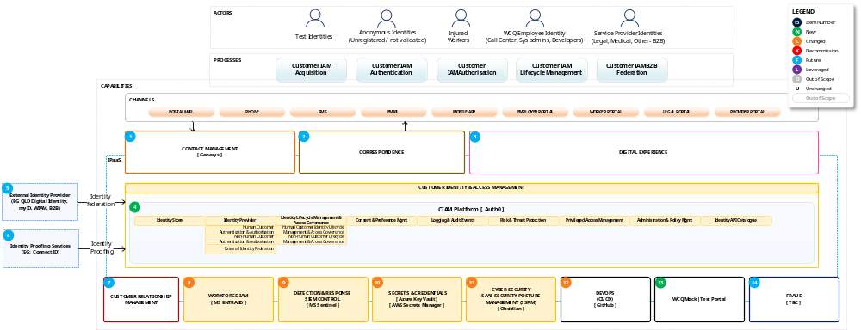
Figure 4 - Application Architecture Diagram
  - Application Architecture Overview
Describes the application landscape that delivers the solution and provides an overview of the key applications, services and platforms involved.
Describe:
- The overall application architecture.
- The primary applications supporting the solution.
- Strategic platforms and shared services.
- Application boundaries and responsibilities.
- The role each application plays within the solution.
This section should provide a business-friendly view of the application landscape without delving into detailed implementation design.
Include:
- Application overview
- Application scope
- Core platforms
- Strategic applications
- Shared services
- Application boundaries
The solution is delivered through a combination of strategic enterprise platforms, customer-facing applications, shared integration services and supporting operational platforms. The architecture promotes reuse of enterprise capabilities while minimising duplication and unnecessary customisation.

  - Application Architecture Principles and Standards
Defines the principles, standards and policies governing application selection, design and lifecycle management.
Describe:
- Application architecture principles.
- Approved technology standards.
- Application lifecycle expectations.
- Reuse and standardisation requirements.
- Enterprise architecture alignment requirements.
These principles help ensure consistency across the application landscape.
Include:
- Application standards
- Approved technologies
- Reuse requirements
- Application lifecycle standards
- Strategic platform requirements
- Vendor product guidelines
Principle | Application
Reuse Before Build | Existing enterprise applications should be reused where possible
Strategic Platform Preference | Approved enterprise platforms should be prioritised
Minimise Customisation | Configuration should be preferred over custom development
Standard APIs | Applications should integrate through approved API standards
Table 7 - Application Architecture Principles and Standards

  - Application Architecture Components
Identifies the major application components and defines their responsibilities within the solution.
[PLACEHOLDER]
Figure 5 - Application Interaction Diagram

Application Component | Responsibility
CIAM (Auth0) | WCQ Cloud Engineering
Workforce IAM (EntraID) | WCQ Cloud Engineering
WCQ Security and Event Management System (SIEM - Sentinel) | WCQ Cloud Engineering
Secrets and credentials (Cloud native secret management) | WCQ Cloud Engineering
SaaS Security Posture Management (Obsidian) | WCQ Cloud Engineering
Observability Platform (DataDog) | WCQ Cloud Engineering
WCQ Mock Portal | WCQ Cloud Engineering
Table 8 - Application Architecture Components

  - Application Architecture Interactions and Flows
Describes how applications communicate, collaborate and exchange information to deliver business capabilities.
[PLACEHOLDER]
Figure 6 - Application Communication Diagram

Source Application | Target Application | Interaction
CIAM (Auth0) | WCQ Mock Portal  Workforce IAM (EntraID)  WCQ Security and Event Management System (SIEM - Sentinel)  Secrets and credentials (Cloud native secret management)  SaaS Security Posture Management (Obsidian)  Observability Platform (DataDog) | Testing purposes  Administrative Single Sign On  Security and audit logging  Secrets management  SaaS security posture management  Platform observability and alerting
Workforce IAM (EntraID) | CIAM (Auth0) | Administrative Single Sign On
WCQ Security and Event Management System (SIEM - Sentinel) | CIAM (Auth0) | Security and audit logging
Secrets and credentials (Cloud native secret management) | CIAM (Auth0) | Secrets management
SaaS Security Posture Management (Obsidian) | CIAM (Auth0) | SaaS security posture management
Observability Platform (DataDog) | CIAM (Auth0) | Platform observability and alerting
WCQ Mock Portal | CIAM (Auth0) | Testing purposes
Table 9 - Application Architecture Interactions and Flows
  - Application Architecture Key Design Considerations
The application architecture supports the core platform deployment into WCQ’s technology environment in preparation for the platform to take on future production workloads. The core application suite enable WCQ Security requirements and enable operational support. The Auth0 CIAM platform is a SaaS capability allowing future extensibility, and an evergreen CIAM capability which can grow in capability and scale with the business in the future.

Consideration | Design Response
Maintainability | Modular SaaS application architecture with clear ownership
Resilience | Critical services designed for high availability
Versioning | API and configuration management versioning standards applied
Scalability | Applications designed to support growth in customer volumes
Operational Support | Monitoring, alerting and support processes incorporated
Security | SIEM logging, advanced cryptography and one way hashing will be utilised in order to protect WCQ’s digital portals and registered digital identities stored withing the Auth0 CIAM platform
Table 10 - Application Architecture Key Design Considerations

  - Application Architecture Checklist
Before completing this section, confirm that:
- The application landscape is clearly described.
- Application standards and principles are documented.
- Major application components have been identified.
- Application responsibilities are clearly defined.
- Interactions and dependencies are understood.
- Maintainability, resilience and scalability have been considered.
- Application architecture aligns with enterprise standards and target-state architecture.
- Stakeholders can understand how applications collaborate to deliver solution outcomes.
A reader should be able to understand what applications comprise the solution, what responsibilities they have, how they interact with each other, and what design considerations influence the application architecture.

- Integration Architecture
This section defines the integration architecture, integration components, information flows and design considerations required to ensure reliable, secure and scalable interoperability across the solution landscape.
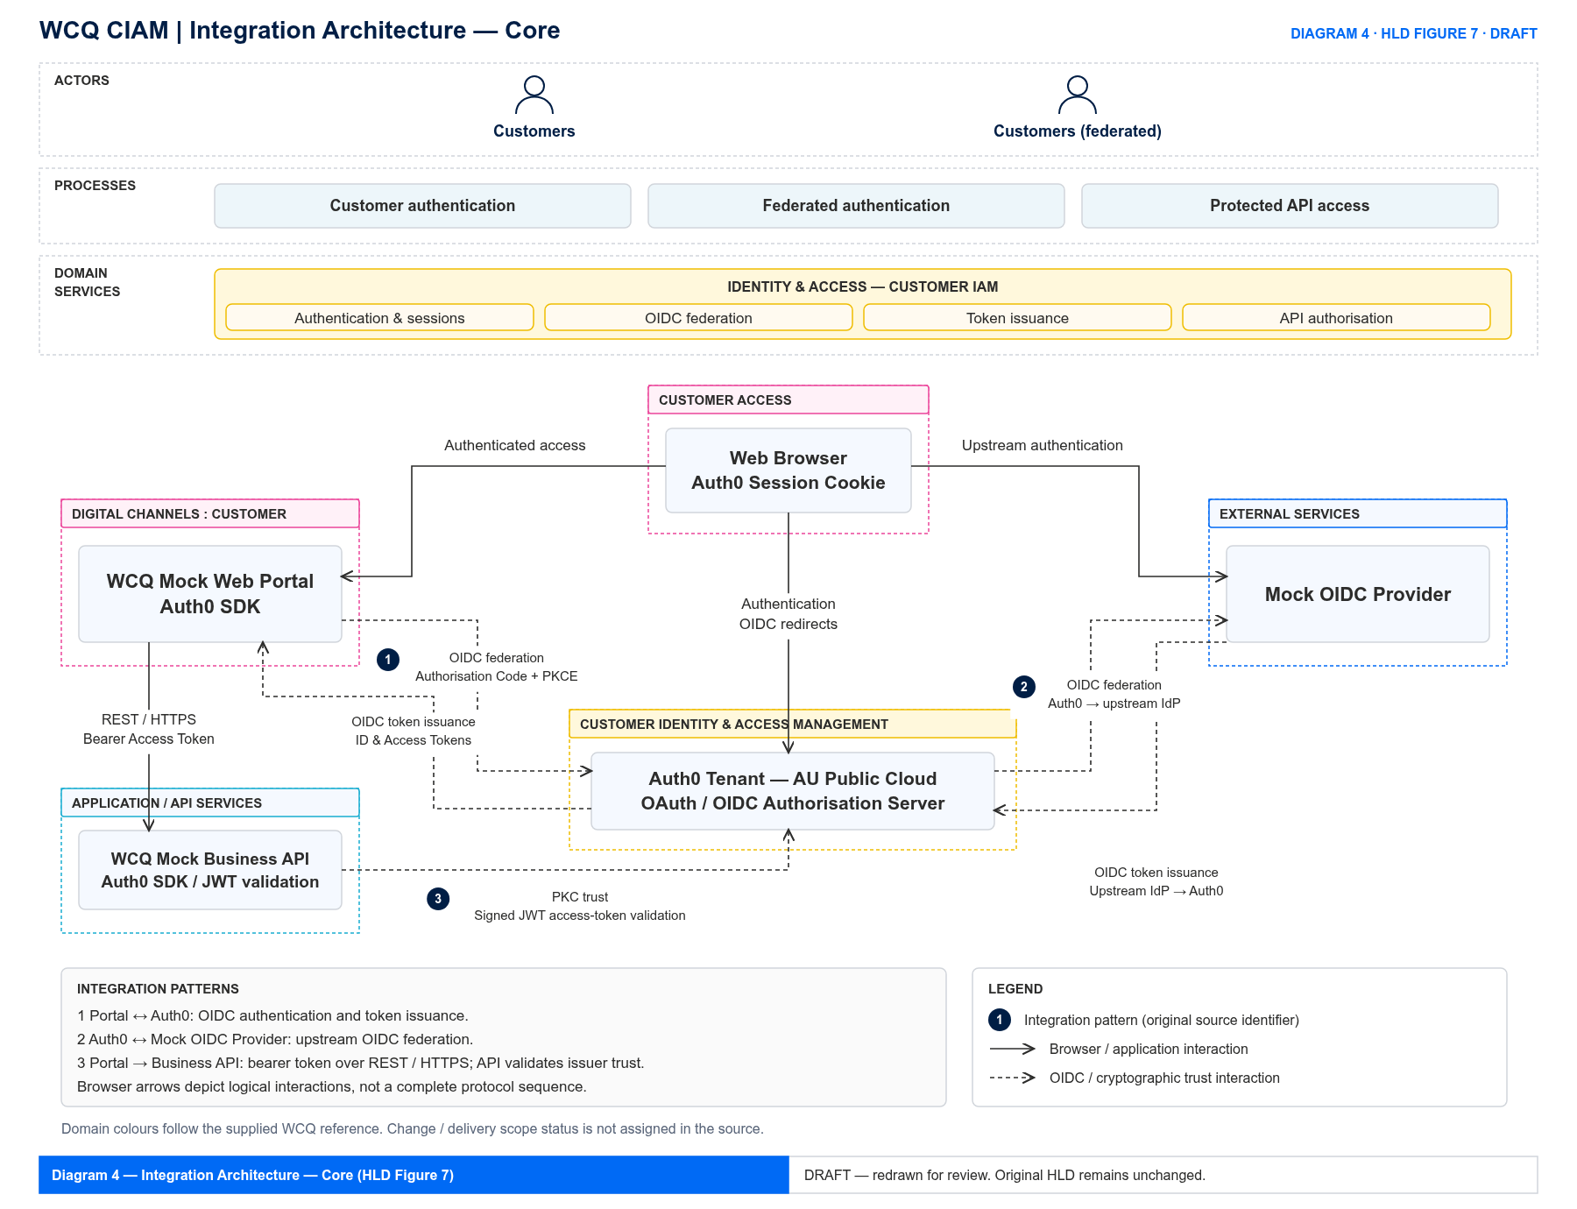
Figure 7 - Integration Architecture Diagram
  - Integration Architecture Overview
The integration architecture for the initial deployment of CIAM includes only the necessary integrations required for the enablement of the of the platform. The platform will not connect to any production digital portals or mobile applications, just the core supporting services which exist today. The integration architecture for CIAM will be iterative and has dependencies on procurement and design of integrated applications.

The integration architecture for WorkCover Queensland (WCQ) adopts a modern, decoupled approach centred around the central Auth0 Tenant deployed in the AU Public Cloud (SaaS). This architecture governs secure user authentication, identity federation, and downstream API communication across both web client and backend application tiers.
Key area of focus is the establishment of the initial CIAM framework that can be iteratively expanded across future releases, key components including the Web Portal, Business API, and OIDC Provider will be mocked, leaving the Auth0 tenant as the primary functional component.
  - Integration Architecture Principles and Standards
The Auth0 CIAM platform will integrate with WCQ applications using WCQ enterprise integration standards and approved integration patterns which adhere to WCQ security standards.
Identity specific patterns include:
- OAuth 2.0 framework – As specified in RFC 9700
  - Business to business / system to system pattern including mobile and native apps – Authorisation code flow with PKCE
  - Note – The OAuth 2.0 Implicit Flow and the Resource Owner Password Credentials flow is deprecated, are deprecated due to security vulnerabilities and are not to be used under any circumstances.
- OIDC – (Business to customer) Open ID Connect is an interoperable authentication protocol based on the OAuth 2.0 framework of specifications. OpenID Connect enables application and website developers to launch sign-in flows and receive verifiable assertions about users across Web-based, mobile, and JavaScript clients. The specification suite is extensible to support a range of optional features such as encryption of identity data, discovery of OpenID Providers, and session logout.
- SAML 2.0 – is an XML-based open standard protocol that enables web-based Single Sign-On (SSO) and cross-domain identity federation. It should only be used as a last resort if it is the only Single Sign-On protocol offered by an application or service which WCQ has business requirements to integrate to.

Principle / Standard | Application
API First | All capabilities are exposed via RESTful APIs, facilitating seamless integration between the WCQ Mock Web Portal, Auth0 Management/Authentication APIs, and backend business APIs.
loose Coupling | Systems interact through standard interfaces and token-based trust models, decoupling client applications, identity providers, and downstream resource APIs from direct implementation dependencies.
Standard Contracts | APIs use Open API specifications and standard JSON payloads. Identity tokens follow standardized JWT schema (RFC9068) structures for self-contained validation across API gateways and services.
Secure by Design | Mandatory HTTPS/TLS 1.3 encryption for all transport channels, OAuth 2.0 Authorization Code Flow with PKCE for web applications, and Client Credentials Grant for machine-to-machine integrations. Note: TLS 1.2 is generally phased out and restricted under modern ASD Information Security Manual (ISM) guidelines in favour of TLS 1.3
Open standards (OIDC & OAuth2.0) | Adopts OpenID Connect (OIDC) for identity assertion and OAuth 2.0 for access authorization, ensuring seamless federation with external providers like the Mock OIDC Provider.
Secure Log Streaming | Real-time tenant audit and operational event streams are transmitted securely over TLS 1.3 endpoints. Operational events stream directly to Datadog, while security audit logs stream via Azure Event Grid through Azure Functions into Microsoft Sentinel for SIEM analytics.
Secure End-User Communication Channels | Outbound notifications and MFA challenges use encrypted REST and SMTP integrations over TLS 1.3/HTTPS with the Correspondence Platform for email, SMS, and voice delivery.
Table 11 - Integration Architecture Principles and Standards

  - Integration Architecture Components
Identifies the integration services, platforms and components that enable communication between systems.
Figure 8 - Interface Topology
Component | Responsibility
API Gateway | Secure API exposure and traffic management
Integration Platform | Service orchestration and data transformation
Event Broker | Event distribution and asynchronous messaging
Message Queue | Reliable message delivery
Partner Gateway | External partner integration services
Table 12 - Integration Architecture Components

  - Integration Architecture Interactions and Flows
This section details the end-to-end logical interactions and message flows between the WorkCover Queensland (WCQ) integration components, external identity providers, log streaming services, and outbound communication channels.

Figure 9 - Sequence / Integration Flow Diagrams

OIDC & OAuth 2.0 Integration Flows
The core customer interaction flow relies on OpenID Connect (OIDC) and OAuth 2.0 protocols to deliver secure user authentication, token issuance, and protected API access. The detailed operational interaction steps across participating components are defined in Table 13 below.

ID | Source | Destination | Interaction
1 | Web Browser / Customer | WCQ: Mock Web Portal | Customer accesses the portal and initiates a self-service registration or login request.
2 | WCQ: Mock Web Portal | Auth0 Tenant (AU Cloud) | Redirects customer browser to Universal Login via Authorization Code Flow with PKCE.
3 | Auth0 Tenant (AU Cloud) | WCQ: Mock Web portal | For federated users, Auth0 redirects to the Mock Web portal for upstream authentication and claims assertion.
4 | Auth0 Tenant (AU Cloud) | Correspondence Platform | Triggers out-of-band MFA challenges and notification delivery via custom Email and Phone providers.
5 | Auth0 Tenant (AU Cloud) | WCQ: Mock Web Portal | Issues ID Tokens and Access Tokens to the client upon successful user authentication.
6 | WCQ: Mock Web Portal | WCQ: Mock Business API | Invokes backend API resources passing the Auth0 Bearer Access Token for PKC trust validation.
7 | Auth0 Tenant (AU Cloud) | Datadog  Sentinel | Streams real-time operational metrics to Datadog and security audit logs to Sentinel.
Table 13 - Integration Architecture Interactions and Flows

  - Integration Architecture Key Design Considerations
The integration architecture for WorkCover Queensland (WCQ) addresses key operational, performance, and security quality attributes to ensure robust and resilient inter-system communication. The table below details these key considerations and the corresponding architectural responses.

Consideration | Design Response
Latency | Optimizes customer-facing interactions via low-latency RESTful API calls and lightweight self-contained OAuth 2.0 / OIDC token validations, supported by Auth0 SaaS multi-region deployment in AWS Sydney and Melbourne.
Reliability | Leverages Azure Event Grid streaming with built-in retry mechanisms and guaranteed message delivery for critical security audit event processing.
Error Handling | Standardizes error responses using HTTP status codes and structured JSON payloads across all REST API interfaces, backed by automated client-side retries and circuit breaking.
Scalability | Employs elastic Auth0 SaaS authentication infrastructure to scale seamlessly (up to public cloud rate limit thresholds) during peak traffic volumes without manual intervention.
Security | Enforces mandatory 1.3 transport encryption, OAuth 2.0 Authorization Code Flow with PKCE, and signed JWT access tokens for API authorization.
Monitoring | Provides end-to-end visibility by streaming operational metrics to Datadog and real-time security audit logs to Microsoft Sentinel via Azure Event Grid.
Availability | Utilizes high-availability multi-region SaaS deployment across AWS Sydney (primary) and Melbourne (warm stand-by) to deliver high service availability and continuous disaster recovery capabilities.
Table 14 - Integration Architecture Key Design Considerations
  - Integration Architecture Checklist
Before completing this section, confirm that:
- The integration landscape is clearly understood.
- Integration principles and standards are documented.
- Major integration components are identified.
- System interactions and data flows are described.
- Interface responsibilities are defined.
- Security requirements have been considered.
- Reliability, scalability and performance requirements are addressed.
- Integration architecture aligns with enterprise integration standards.
A reader should be able to understand how systems communicate, what integration technologies and patterns are used, how information flows between components, and what design considerations govern the integration architecture.

- Data Architecture
This section defines the data architecture required to support business capabilities, information flows, reporting, integration and compliance obligations while ensuring the quality, security and integrity of information assets.
[PLACEHOLDER]
Figure 10 - Data Architecture Diagram
  - Data Architecture Overview
Describes how data is organised, owned, managed and governed within the solution landscape.
The data architecture focuses on three core data domains:
    - End-user profile data (Digital identity):
Customer PII stored in the Auth0 production tenant will be minimized to just enough PII to allow an external user to authenticate to a WorkCover Queensland business portal and will not contain any other business specific data elements not required for authentication. Opaque immutable identifiers for the user object such as GUID, External ID, CRM ID and credentials (passwords, passkeys) are considered identity attributes and can be stored as part of a user profile in Auth0.
Data classification: Protected
    - Auth0 tenant configuration data
Auth0 configuration data for which the GitHub source control repository serves as the authoritative source of truth.
Data classification: Protected
    - Auth0 audit and security logs
Are retained natively within Auth0 for 30 days, while retention for streamed audit log retention duration within the WCQ SIEM can be enforced separately in accordance with organisational governance policies.
Data classification: Protected

  - Data Architecture Principles and Standards
Principle | Application
Single Source of Truth | Digital profile Data: will have an authoritative source system and will be dependent on the relevant business capability such as:  Claims portal or Provider portal and upstream data sources.  MFA attributes (Email address and mobile phone number) require real-time bi-direction synchronisation as they are updated via self-service through digital portals or via assisted service channels and have real-time end user implications.  Identity Verification Data: Will be validated leveraging verifiable credential providers as authoritative sources such as MyID, ConnectID or State and Territory based Government ID (QDI, NSW Digital ID, etc).  Configuration data: GitHub source control serves as the authoritative source of truth for all Auth0 tenant configurations, enabling repeatable deployments and version control via IaC.
Data Ownership | Every data domain must have a business owner. The business domains will own the cohort data specific to the digital business service consumed.
Data Quality | Data quality controls must be implemented at both business and digital layers and must conform to OWASP protective data validation controls.
Data Minimisation | End-user PII stored within the identity repository is strictly limited to essential attributes, supplemented by non-PII external identifiers. Only authentication data attributes will be stored in Auth0.
Information Reuse | Information should be shared rather than duplicated
Data governance | Identity data and configuration assets are completely segregated and managed under established governance policies, defining clear ownership, lifecycle retention, and change management standards. All data access will be on a strict need-to-know basis.
Data Security | All sensitive credentials (passwords, passkeys) and user profile data are protected using strong encryption standards in transit and at rest, maintaining strict confidentiality and integrity. Passwords stored in the Auth0 platform are cryptographically hashed using the standard BCrypt algorithm.
Table 15 - Data Architecture Principles and Standards

  - Data Architecture Components
This section will be completed when the CIAM platform integrates to core business applications. This avoids any assumptions regarding the future state where some applications and capabilities are currently undefined.
Identifies the major data repositories, stores and information management components that support the solution.
[PLACEHOLDER]
Figure 11 - Data Store Model

Data Component | Purpose
Customer Identity Repository  (Auth0 Identity Store) | Managed directly within the Auth0 SaaS Tenant hosted in the AU Public Cloud across AWS Sydney and Melbourne regions. It stores minimal end-user identity attributes (PII)—restricted strictly to email address and phone number—alongside non-PII attributes such as external identity provider identifiers. It also securely manages user credentials, storing passwords cryptographically hashed using BCrypt and supporting modern phishing resistant and passwordless authentication.
Configuration Management Repository  (GitHub Source Control) | GitHub Serves as the authoritative source of truth for all Auth0 tenant environments, configurations, enabling repeatable deployments and version control.  All tenant settings, connection definitions, branding static assets, and custom business logic (Pre-Registration and Post-Login Actions) are declared as code in GitHub and deployed automatically via CI/CD pipelines utilizing the Auth0 Terraform Provider.
Security Information and Event Management Repository  (SIEM) | Microsoft Sentinel is the WCQ SIEM which stores audit and security events and can provide specific alerts to Security operations when configured.
Observability and Reporting Platform  (Datadog) | Datadog will provide monitoring, performance and dashboard views of WCQ Auth0 instances
Table 16 - Data Architecture Components

  - Data Architecture Interactions and Flows
Describes how data moves, transforms and is maintained throughout the solution lifecycle.
[PLACEHOLDER]
Figure 12 - Information Flow Diagram

Source | Destination | Purpose
End-User browser | Auth0 | User authentication, registration, credential submission, and OIDC token exchange (ID & Access Tokens) via standards-based Proof Key for Code Exchange (PKCE) flow. All such user data will be stored securely in the Auth0 Public Cloud infrastructure.
Identity Platform Auth0 | WCQ authoritative sources such as CRM, Claims management, Provider management systems. These will be defined when Auth0 integrates to digital business portals and will form part of their designs for external access requirements for each specific cohort. | Customer profile synchronisation. Synchronisation of user profile attributes (email, phone number) and external identity references as defined in future digital portal designs
Identity Platform Auth0 | Microsoft Sentinel (SIEM) | Real-time audit and security log streaming for SIEM compliance archiving and threat analysis
Identity Platform Auth0 | Datadog observability and reporting platform | Provides monitoring, performance and dashboard views of WCQ Auth0 instances
Identity Platform Auth0 | External Identity Provider | Business to Business federation for digital portal single sign on. (White labelled B2B services)
Identity Platform Auth0 | External Identity Verification Providers | End user Identity verification
Table 17 - Data Architecture Interactions and Flows

  - Data Architecture Key Design Considerations
Identifies the major requirements, constraints and risks influencing the design and governance of data.

Consideration | Design Response
Privacy | Personal information protected in accordance with privacy obligations
Data Sovereignty | The Auth0 tenant is hosted in Australia. The Auth0 platform’s primary high availability location is Sydney with and Melbourne as a warm standby location.
Data Quality | Validation controls must be implemented at staff and end user data entry points (on the web and mobile applications as well as server-side). End-user email addresses and mobile phone numbers must be formatted correctly and must be verified for ownership before storing within WCQ systems.
Retention | Auth0 audit logs retained natively for 30 days and logs will be streamed to the WCQ SIEM inheriting organization retention policies.
Compliance | Audit trails will be maintained in the WCQ SIEM.
Table 18 - Data Architecture Key Design Considerations

  - Data Architecture Checklist
Before completing this section, confirm that:
- Data domains and ownership have been identified.
- Information architecture is understood.
- Data governance principles are documented.
- Key data stores and repositories are identified.
- Information flows and synchronisation requirements are understood.
- Privacy, sovereignty and retention obligations are addressed.
- Data quality requirements are defined.
- Data architecture aligns with enterprise data standards and governance requirements.
A reader should be able to understand what information the solution manages, where it is stored, who owns it, how it moves between systems, and what governance, quality, privacy and compliance requirements influence the data architecture.

- Information Security Architecture
This section describes the security principles, classifications, controls, risks and compliance obligations that guide the design and operation of the solution and ensure alignment with enterprise security requirements.

[PLACEHOLDER]
Figure 13 - Information Security Architecture Overview

  - Information Security Overview
Provides a high-level overview of the security architecture and the approach used to protect information, services and technology assets.

The Auth0 CIAM solution adopts a secure resilient, and business-enabled environment, incorporating identity management, access controls, encryption, monitoring and audit capabilities throughout the architecture. Security controls are aligned with enterprise policies and regulatory obligations to ensure the protection of customer, business and operational information.
The solution leverages a shared SaaS security model where the vendor Auth0 provides appropriate, certified, audited platform security controls. Whilst Auth0 secures the Auth0 SaaS platform, WCQ’s information security responsibility is broad and must at a minimum, cover the following:
- Enforce strong authentication for staff, integrators, and external end users of the platform
- Enforce ASD recommended security controls to all internet facing portals which consume CIAM services.
- Secure integrations, data, and CI/CD pipelines integrated to the CIAM platform with regular secret, key and PKI rotation as per WCQ’s internal policy.
- Implement granular access controls following the principle of least privilege.
- Enforce governance of the Vendor, Integrator, CIAM platform, connected applications, first and third-party integrations ensuring appropriate logging and accounting is replicated to the WCQ SIEM.
- Security posture management is in place and reviewed regularly.
- Secure development lifecycle practices are followed.
- Deprecated, legacy encryption and identity integration standards are strongly discouraged for use with the Auth0 CIAM platform.

  - Information Security Principles and Standards
Defines the security principles, standards and policies that govern the design, implementation and operation of the solution.

Principle | Description
Security by Design | Security requirements incorporated from the outset of design activities
Least Privilege | Access granted only to the minimum level required
Defence in Depth | Multiple layers of security controls applied
Zero Trust | All access requests are verified and validated
Secure by Default | Systems are deployed with secure baseline configurations
Table 19 - Security Principles

  - Information Security Classification and Handling
Defines how information is classified, protected, stored, transmitted and disposed of throughout its lifecycle.
The information in the table is referenced from the WCQ Information Asset Classification policy which aligns to Queensland Government Information Security framework (QGISCF)

Classification | Description | Key Handling Requirements
Unclassified | UNCLASSIFIED Information includes any Information which is not owned by WorkCover nor does WorkCover have any responsibility to protect or handle it in relation to any legal or contractual obligation.  Examples of UNCLASSIFIED Information include:  - Information or Data which is publicly available on Internet sites.  - Information freely provided to WorkCover without any binding legal obligations.  - Information which is not owned nor under any legal custodianship of WorkCover.  - A brochure from a public website. | No specific handling requirements
Unofficial | UNOFFICIAL Information includes any Information that is not owned or used by WorkCover in the delivery of its official services under any legislation or contractual obligations.  Examples of UNOFFICIAL Information include:  - An employees personal or private appointment using WorkCover Information Assets. | No specific handling requirements
Public | PUBLIC Information is information which is owned by WorkCover and has been deemed suitable & approved for public distribution and access by any persons or entities.  N.B. Public information may still require integrity or availability requirements.  Examples of PUBLIC Information include:  - WorkCover’s Internet website  - WorkCover’s Annual Report once approved and published on the OIR Internet website | No specific handling requirements
Official | OFFICIAL Information is routine Information without special Sensitivity or Handling requirements. Compromise to the Confidentiality of the Information may cause Minor Impact to WorkCover, Queensland or Federal Government, partners, stakeholders, commercial entities or members of the public.  Examples of OFFICIAL Information includes:  - General personal information relating to Employees (such as names, titles, departments and phone numbers)  - Inter-office or department or agency emails of a general nature and not containing claims information, Personal Identifiable or Sensitive Personal Information. | Access limited to authorised personnel only
Official: Sensitive | OFFICIAL: SENSITIVE Information is Information that requires additional handling, care and security controls. Compromise to the Confidentiality of the Information may cause a Substantial/Serious Impact to WorkCover, Queensland or Federal Government, partners, stakeholders, commercial entities or members of the public.  Examples of OFFICIAL: SENSITIVE Information may include:  - Legal professional privilege as defined by legislation  - Personally Identifiable Information  - Information about businesses WorkCover insures e.g. payrolls, staffing numbers, injury rates, premium amounts | Strong access controls, monitoring, storage and transmission protections are expected to prevent unauthorised disclosure.  Access limited to authorised personnel only
Protected | PROTECTED Information is Information with a Very Serious/Disaster Impact level, whose compromise could cause actual significant damage to the WorkCover, Queensland or Federal Government, partners, stakeholders, commercial entities or members of the public. Compromise could directly endanger individuals’ lives and/or cause significant harm.  Examples of PROTECTED Information may include:  - Legal professional privilege as defined by legislation  - High volumes of Personally Identifiable & Sensitive Personal Information  - Login credentials (passwords, authentication tokens, API keys, MFA recovery codes, privileged account credentials)  - Personal information that people normally consider to be private  - Data about businesses WorkCover insures e.g. payrolls, staffing numbers, injury rates, premium amounts | Strong access controls, monitoring, storage and transmission protections are expected to prevent unauthorised disclosure.  Protected information must only be stored or processed in Australia unless an approved offshore risk acceptance has been signed by the accountable officer.  Access limited to authorised personnel only
Table 20 – WCQ Information Classification Levels

Information Security Controls
The following table defines the security controls required to protect WCQ’s information, systems and business services.
WCQ derives its Information Ssecurity policies from:
- The Australian Signals Directorate (ASD)
- National institute of Standards and Technology (NIST Cyber Security Framework (CSF) 2.0)
- Australian Prudential Regulation Authority
- Queensland Government Information and cyber security policy (IS18)
- Queensland Government Information Security Classification Framework (QGISCF)

The Auth0 CIAM solution and all core and future integrations will adhere to the WCQ corporate governance policies as defined on the WCQ intranet.

Security Domain | Controls
Identity & Access Management | Role-Based Access Controls (RBAC)  Strong, phishing resistant authentication  Multi-Factor Authentication (MFA)  Single Sign On – Identity Operations platform management  Single Sign On – Federated business applications and B2B white labelling  Identity threat mitigation controls: Attack protection – Bot protection, Breached password protection, Brute force protection, Suspicious IP throttling)  Standards based identity protocols: OAuth 2.0, PKCE, OIDC and SAML 2.0 only if OAuth 2.0 and OIDC are not supported.
Data Protection & Privacy | Data encryption in transit (TLS 1.3).  Data encryption at rest (AES-256).  Credential one way hashing (BCrypt with 128bit salt – 10 rounds)  Future state - Limited PII stored in the production Auth0 CIAM environment  Post platform deployment – No PII stored in production environment  Dummy data stored in all non-production Auth0 CIAM environments  Mandatory usage of privacy preserving identity standards / protocols such as OAuth 2.0, PKCE, OIDC  Regular configuration and data backups (Encrypted)
Application Security | SaaS responsibility model applies.  Auth0 CIAM SaaS platform security – Auth0 vendor responsibility. This was assessed during the procurement process, and attestations are provided on the vendor website and sighted by WCQ.  WCQ responsible for end-to-end security of CIAM integrated applications using applicable security and application integration standards, i.e. Safe coding standards (OWASP), code vulnerability management, 3rd party reviews, testing.  Vulnerability management and threat mitigation
Infrastructure and platform security | SaaS security is a shared responsibility model, the vendor Auth0 secures the underlying cloud infrastructure, physical data centres, core platform code, and uptime. The customer WCQ, retains full responsibility for protecting our own data, managing user access/identities, configuring application security settings, and monitoring activity.  The platform runs on the Australian AWS cloud and leverages AWS security capabilities.  The security controls are audited for compliance purposes which Auth0 make available on their website.
Communications and network security | Whilst dedicated point to point networking is only applicable in certain circumstances, CIAM communications traverse the public internet, hence strict encryption standards must be followed for example: Encryption in transit to utilise HTTPS / TLS 1.3.  API security is critical for CIAM communications and must ensure the protection of data payloads and mitigate against threats such as JSON hijacking, injection, pollution and unauthorised access.  Developers must enforce strict validation, safe parsing and proper transport encryption.  Developers and integration teams must follow JSON Web Token Best Current practices RFC:  https://www.rfc-editor.org/info/rfc8725/
Security operations and monitoring | Centralised security logging and alerting will be configured to pull logs from Auth0 tenants securely for Secruity Operations, monitoring, Alerting, platform Observability and log preservation.  Security Operation logs will be made available in the WCQ Microsoft Sentinel SIEM  Monitoring and observability logs will be made available in WCQ Datadog instance.
Security assessment and testing | Pre-production release penetration testing and remediation, vulnerability management, regular patching, code scanning and remediation.
Risk and Compliance management | Adherence to the WCQ Cyber Security Risk management policy to manage the loss of confidentiality, integrity, or availability of information, data, or information systems and the potential adverse impacts to organisational operations and assets, individuals, other organisations.
Business continuity and resilience | Resilience - The Auth0 SaaS platform is deployed in AWS Sydney region across two separate availability zones. A warm standby site is in the AWS Melbourne region for emergency failover should the need arise.  Business continuity plan will be developed as part of the production handover to support process in accordance with the WCQ ICT Service Continuity and Disaster Recovery Policy.
Third party and Supply Chain Security | Third party and Supply Chain Security assessments are carried out during procurement processes to mitigate associated risks  Third party software components including open-source software should be assessed with alignment to WCQ policies to mitigate associated risks.  Risk assessments may be carried out on an ongoing basis subject to WCQ’s policies and risk management framework.
Governance and security assurance | The WCQ ICT Governance policy applies.  The CIAM platform, integrations and associated applications and business processes are subject to the WCQ risk strategy, policies, and leadership accountability, ensuring cyber risk is treated as a core business risk.  The CIAM platform, integrations and associated applications and business processes are subject to audit to measure control effectiveness to ensure protection of confidentiality, integrity, and availability meet regulatory requirements.
Table 21 - Information Security Controls

  - Threats, Risks and Mitigations
Identifies key security threats and risks that may affect the solution and the controls implemented to reduce those risks.

Example
Threat / Risk | Impact | Mitigation
Unauthorised access | Data breach or service misuse | MFA, RBAC, access reviews and data encryption
Credential compromise | Identity takeover | Conditional Access and MFA. SIEM log interrogation and Fraud investigations
Malware or ransomware | Service disruption and data loss | Endpoint protection and backups
Data leakage | Regulatory and reputational impact | Encryption and data loss prevention controls
Privilege misuse | Unauthorised activity | Privileged access management and monitoring
Table 22 - Security Risks and Mitigations

  - Security Compliance Requirements
Defines the security, regulatory and compliance obligations that must be satisfied by the solution.

Requirement | Compliance Approach
Privacy Obligations | Personal information protected through access controls and encryption
Security Monitoring | Security events collected and monitored
Audit Requirements | Audit trails retained in accordance with policy
Data Retention Requirements | Information retained and disposed of according to approved schedules
Access Reviews | Periodic review and certification of access rights
Table 23 - Security Compliance Requirements

  - Information Security Checklist
Before completing this section, confirm that:
Security Architecture
- Security objectives have been defined.
- Security responsibilities are understood.
- Security principles and standards have been identified.
- Security requirements have been incorporated into the solution architecture.
Information Protection
- Information classifications have been identified.
- Handling requirements are defined.
- Data protection controls are documented.
- Information lifecycle considerations have been addressed.
Security Controls
- Appropriate preventative, detective and corrective controls are implemented.
- Identity and access management requirements are defined.
- Monitoring and audit controls are documented.
- Incident response requirements have been considered.
Security Risk and Compliance
- Security threats and risks have been assessed.
- Mitigation controls are documented.
- Regulatory and compliance obligations have been identified.
- Residual risks are understood and accepted.
A reader should be able to understand how information is protected, which security principles and controls have been applied, what threats and risks exist, and how the solution satisfies organisational security and compliance requirements.
- Security Architecture
Purpose: Describes how security requirements are addressed within the solution to protect information, systems, services and users. This section defines the security architecture, controls, principles and services required to manage risks, meet compliance obligations and support secure business operations.
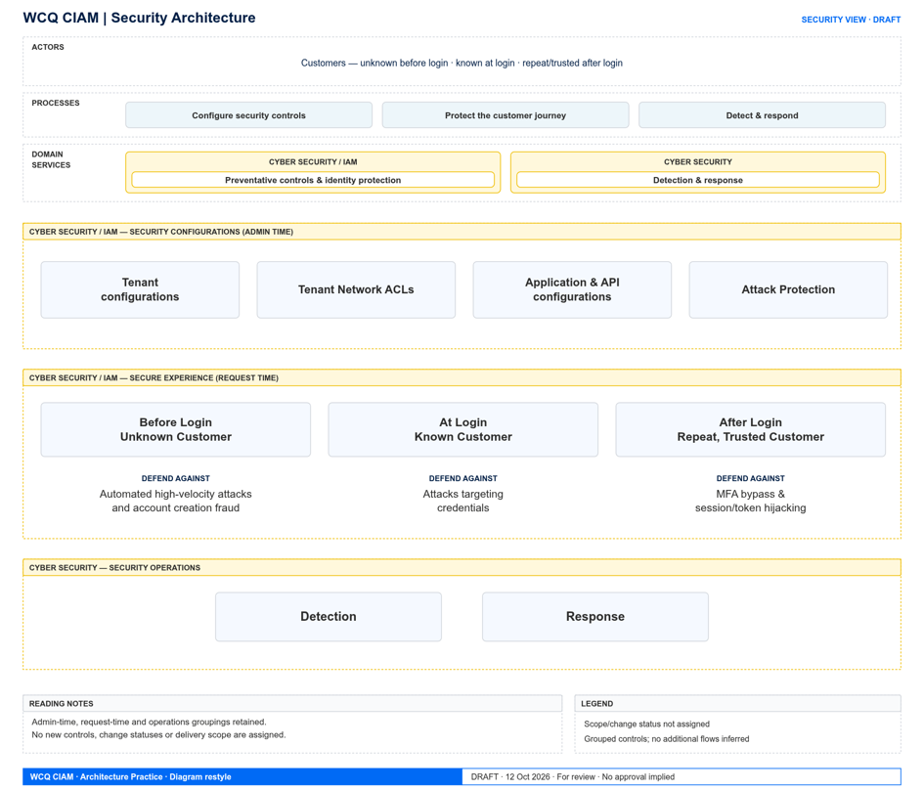

Figure 15 - Security Architecture Diagram
  - Security Architecture Overview
Describes how security requirements are addressed within the solution and provides an overview of the security architecture approach.
Figure 15 illustrates the comprehensive Security Architecture model, structured across three operational tiers:
- Security Configurations (Admin time): Establishes foundational security policies and administrative controls, encompassing baseline tenant configurations, network Access Control Lists (ACLs), application and API authorization settings, and Attack Protection Suite rules.
- Secure Experience (Request time): Governs dynamic runtime protection across user interaction stages: defending against automated high-velocity attacks and account creation fraud for unknown customers before login; safeguarding against credential targeting and password attacks for known customers at login; and protecting against MFA bypass, session hijacking, and token replay for repeat, trusted customers after login.
- Security Operations (Ops time): Provides operational oversight through threat detection analytics and automated incident response capabilities. Auth0 will stream tenant audit logs to SIEM systems like Datadog and Sentinel. Downstream thresholds, alerts & dashboards may be configured there.

The Auth0 SaaS solution adopts a security-by-design approach that incorporates identity management, access control, data protection, monitoring and audit capabilities throughout the solution lifecycle. Security controls are aligned to enterprise security standards, regulatory obligations and risk management requirements.
From a compliance point of view, Okta, the parent company of Auth0 has comprehensive certification information and documentation available at the following links:
- Okta Security Trust Centre
- Okta threat intelligence research and advisories
- Okta Security Blog

  - Security Architecture Principles and Standards
Defines the security principles, standards and policies that govern security architecture and implementation.
Principle | Application
Security by Design | Security requirements incorporated from project inception
Zero Trust | All users and services are verified before access is granted
Least Privilege | Access is restricted to the minimum required permissions
Defence in Depth | Multiple layers of security controls are implemented
Secure by Default | Systems are configured with secure default settings
Table 24 - Security Architecture Principles and Standards

  - Security Architecture Components
Identifies the security services, controls and platforms used to protect the solution.
[PLACEHOLDER]
Figure 16 - Security Controls Model

Security Component | Responsibility
Identity Provider | Authentication and identity management
Access Management Service | Role and permission management
Multi-Factor Authentication Service | Enhanced user verification
Security Monitoring Platform | Threat detection and audit monitoring
Encryption Service | Data protection and key management
Audit Logging Service | Security and compliance logging
Table 25 - Security Architecture Components

  - Security Architecture Interactions and Flows
Describes how security controls operate across users, systems, services and data flows.
[PLACEHOLDER]
Figure 17 - Authentication / Authorisation Flow

Interaction | Purpose
User → Identity Platform | Authentication and identity verification
Identity Platform → Access Service | Authorisation and role validation
Identity Platform → Audit Service | Security activity logging
Audit Service → Monitoring Platform | Security monitoring and alerting
Application → Encryption Service | Secure data storage and protection
Table 26 - Security Architecture Interactions and Flows

  - Security Architecture Key Design Considerations
Identifies the major security risks, obligations and architectural considerations influencing the security design.
Consideration | Design Response
Unauthorised Access | Multi-factor authentication and role-based access control implemented
Data Breach Risk | Encryption applied in transit and at rest
Regulatory Compliance | Audit logging and reporting capabilities implemented
Insider Threat Risk | Privileged access monitoring and segregation of duties enforced
Privilege Escalation Risk | Least-privilege model and approval workflows implemented
Table 27 - Security Architecture Key Design Considerations

  - Security Architecture Checklist
Before completing this section, confirm that:
- Security objectives and scope are clearly defined.
- Applicable security principles and standards are documented.
- Identity, access and data protection controls are identified.
- Security services and responsibilities are understood.
- Authentication, authorisation and audit flows are documented.
- Threats and vulnerabilities have been considered.
- Regulatory and compliance obligations are addressed.
- Security controls align with enterprise security standards and risk appetite.
A reader should be able to understand how the solution protects users, systems and information, what security controls are implemented, how access is managed, how security events are monitored, and how security risks and compliance obligations are addressed.

- Infrastructure Architecture
Purpose: Describes the infrastructure platforms, hosting environments, platform services and foundational technology capabilities that support the solution. This section defines the infrastructure architecture required to deliver the solution's availability, resilience, scalability, performance and operational requirements.
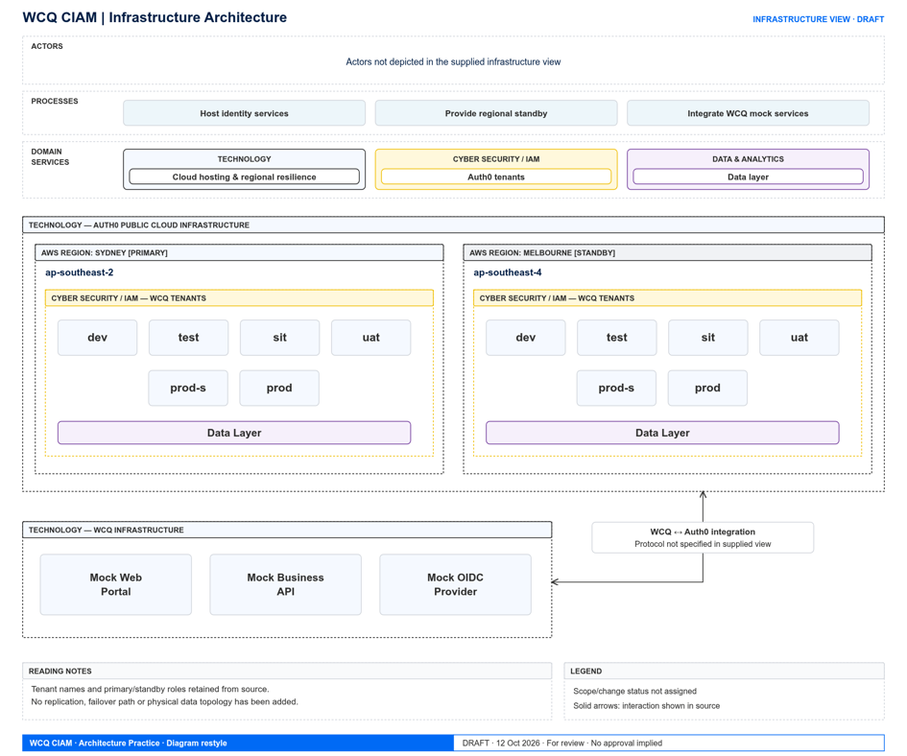
Figure 18 - Infrastructure Diagram
  - Infrastructure Architecture Overview
The infrastructure architecture for WorkCover Queensland (WCQ) adopts a cloud-first, fully managed Software-as-a-Service (SaaS) hosting strategy centred around the Auth0 SaaS platform. The solution is deployed within the Auth0 Australian Public Cloud tenant, utilizing multi-region infrastructure spanning AWS Sydney (primary region) and AWS Melbourne (warm standby) to ensure high availability, automatic scaling, and geo-redundant disaster recovery without requiring custom server provisioning.
This section should provide a high-level view of the infrastructure landscape without detailing specific configurations.

    - Hosting & Platform Strategy
Fully Managed SaaS Hosting: Core identity and access management components—including Universal Login, MFA authenticators, and token issuance services—are hosted as managed multi-tenant SaaS services within Auth0's Australian cloud infrastructure.
High Availability & Multi-Region Failover: The Auth0 SaaS platform operates across AWS Sydney (primary) and AWS Melbourne (warm standby) availability zones, delivering continuous availability and regional failover for identity operations.
Managed Enterprise Integrations: Integrates with enterprise cloud platform services including WCQ Azure Cloud (Azure Event Grid and Functions for SIEM log streaming to Microsoft Sentinel), WCQ Datadog Service for operational telemetry, and WCQ Correspondence Platform for out-of-band email and SMS delivery.
Automated Infrastructure as Code (IaC): All tenant infrastructure configurations, branding assets, custom Actions logic, and connection definitions are declared as code in GitHub and deployed via automated CI/CD pipelines using the Auth0 Terraform Provider.

  - Infrastructure Architecture Principles and Standards

Principle / Standard | Application
Cloud First | Leverages the fully managed Auth0 Public Cloud SaaS platform hosted in Australian cloud regions, eliminating server infrastructure overhead and maintenance.
Infrastructure as Code | All tenant settings, connections, rules, branding assets, and custom Actions are declared in GitHub source control and provisioned via automated Terraform CI/CD pipelines.
Standard Platforms & managed services | Integrates with enterprise-approved platforms, including Azure Event Grid, Azure Functions, Microsoft Sentinel for SIEM, Datadog for telemetry, and the Correspondence Platform for MFA/notifications.
Secure by Default | Enforces strict security baselines, mandatory TLS 1.3 transport security, AES-256 encryption at rest, BCrypt credential hashing, and encrypted log streaming endpoints.
High Availability & multi region geo-redundancy | Deploys across AWS Sydney (primary) and AWS Melbourne (warm standby) availability zones to provide uninterrupted identity operations, automated regional failover, and disaster recovery.
Table 28 - Infrastructure Architecture Principles and Standards

  - Infrastructure Architecture Components
Identifies the infrastructure components and platform services required to support the solution.
[PLACEHOLDER]
Figure 19 - Hosting Architecture

Infrastructure Component | Responsibility
Auth0 SaaS Platform (AU Cloud) | Secure connectivity between services
SIEM – Microsoft Sentinel | Security log streaming for ingesting security audit trails into Microsoft Sentinel
WCQ Datadog Service | Hosts real-time operational telemetry, health monitoring, and performance tracking infrastructure.
WCQ Correspondence Platform (Platform TBC) | Infrastructure services supporting outbound delivery of email notifications and SMS/voice OTP messages.
GitHub CI/CD & Terraform Pipeline | Automates Infrastructure as Code (IaC) deployment pipelines and configuration management across environments.
Table 29 - Infrastructure Architecture Components

  - Infrastructure Architecture Interactions and Flows
Describes how infrastructure components interact and provide services to support solution operation.
[PLACEHOLDER]
Figure 20 - Connectivity Diagram
Source Component | Target Component | Purpose
WCQ Mock Web Portal | Auth0 SaaS Platform (AU Cloud) | Used to test and showcase user authentication redirection and token acquisition via OIDC Authorization Code Flow with PKCE over HTTPS/TLS.
Auth0 SaaS Platform (AU Cloud) | WCQ Sentinel | Secure real-time log streaming of tenant security audit events over TLS 1.3 for ingestion into Microsoft Sentinel SIEM.
Auth0 SaaS Platform (AU Cloud) | WCQ Datadog Service | Direct streaming of operational logs and platform telemetry over TLS 1.3 for real-time monitoring and alerting.
Auth0 SaaS Platform (AU Cloud) | WCQ Correspondence Platform | Out-of-band delivery of MFA challenges, SMS OTP codes, and email verification notifications via REST/TLS 1.3 interfaces.
GitHub CI/CD & Terraform Pipeline | Auth0 SaaS Platform (AU Cloud) | Automated deployment and provisioning of tenant configurations, Actions, connections, and settings as code via Auth0 Management API.
Table 30 - Infrastructure Architecture Interactions and Flows
  - Infrastructure Architecture Key Design Considerations
Identifies the primary infrastructure requirements, constraints and quality attributes that influence infrastructure design decisions.

Consideration | Design Response
Availability | Auth0 SaaS infrastructure designed to support 99.99% monthly availability
Scalability | Elastic Auth0 SaaS multi-tenant infrastructure automatically scales to handle peak authentication traffic within public cloud rate limits.
Resilience | High-availability multi-region SaaS deployment across AWS Sydney (primary) and Melbourne (warm standby) eliminates single points of failure.
Capacity | Cloud-native SaaS infrastructure sized to support expected user volumes and growth up to 100 RPS sustained for Authentication API.
Disaster Recovery | Geo-redundant automated failover to AWS Melbourne with RPO of 1 minute and RTO of 15 minutes for regional disaster recovery.
Operational Support | Fully managed Auth0 SaaS handles OS, patching, and maintenance, with operational log streaming to Datadog for health telemetry.
Table 31 - Infrastructure Architecture Design Considerations

  - Infrastructure Architecture Checklist
Before completing this section, confirm that:
- The hosting model is clearly defined.
- Infrastructure standards and principles are documented.
- Major infrastructure services and platforms are identified.
- Connectivity and infrastructure dependencies are understood.
- Capacity, availability and resilience requirements are addressed.
- Disaster recovery and operational support requirements are considered.
- Infrastructure aligns with enterprise hosting and cloud strategies.
- Infrastructure supports current and future business demand.
A reader should be able to understand where the solution is hosted, what infrastructure services support it, how infrastructure components interact, and how the architecture delivers the required levels of availability, resilience, scalability and operational support.
- Environment Architecture
The environment strategy for WorkCover Queensland (WCQ) relies on a multi-tiered tenant topology to ensure complete isolation, controlled promotion, and reliable delivery across the software development lifecycle. The architecture comprises six distinct Auth0 environments, each serving a dedicated operational purpose. Each environment corresponds to an independent Auth0 tenant. Similarly, other core components viz. Mock Web Portal, Mock Business API and Mock OIDC Provider will also have their own distinct corresponding environments.
- Development (DEV): Dedicated sandbox environment used by development teams for active feature engineering, initial custom Actions development, and unit testing.
- Test (TEST): Supports rapid verification, automated test suites, and functional validation of new identity features and tenant configuration changes.
- System Integration Test (SIT): Validates end-to-end identity flows and interface protocols between Auth0 and interconnected enterprise systems, including mock and external identity providers.
- User Acceptance Testing (UAT): Provides a stable, production-like environment for business stakeholders, QA teams, and customer representatives to perform final validation and user acceptance sign-offs.
- Production (PROD): The live customer-facing identity platform environment, hosted across AWS Sydney and Melbourne for high availability, fault tolerance, and security compliance.
- Production Support (PROD-SUPPORT): A pre-production staging environment mirrored closely with production settings, used for dry-run deployment rehearsals, defect replication, patch verification, and operational readiness testing.

The solution will utilise separate environments to support controlled delivery and operational stability. Each environment serves a distinct purpose and supports the progressive validation of solution capabilities prior to production deployment. Each environment will be built via CI/CD deployment automation.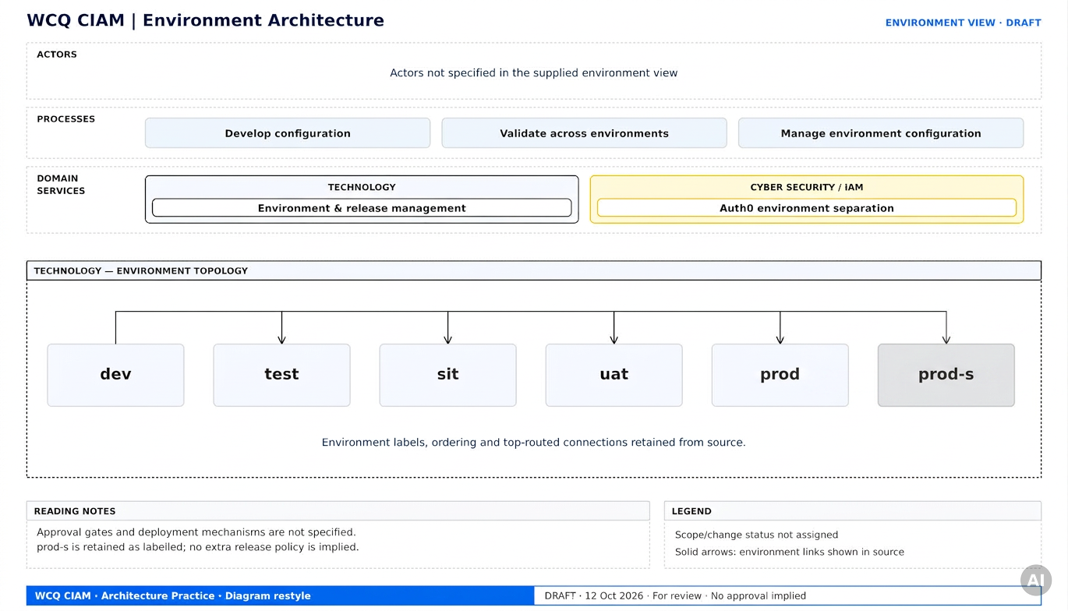
Figure 21 - Environment Topology Diagram
  - Environment Architecture Overview
The environment strategy for WorkCover Queensland (WCQ) relies on a multi-tiered tenant topology to ensure complete isolation, controlled promotion, and reliable delivery across the software development lifecycle. The architecture comprises six distinct Auth0 environments, each serving a dedicated operational purpose. Each environment corresponds to an independent Auth0 tenant. Similarly, other core components viz. Mock Web Portal, Mock Business API and Mock OIDC Provider will also have their own distinct corresponding environments.
- Development (DEV): Dedicated sandbox environment used by development teams for active feature engineering, initial custom Actions development, and unit testing.
- Test (TEST): Supports rapid verification, automated test suites, and functional validation of new identity features and tenant configuration changes.
- System Integration Test (SIT): Validates end-to-end identity flows and interface protocols between Auth0 and interconnected enterprise systems, including mock and external identity providers.
- User Acceptance Testing (UAT): Provides a stable, production-like environment for business stakeholders, QA teams, and customer representatives to perform final validation and user acceptance sign-offs.
- Production (PROD): The live customer-facing identity platform environment, hosted across AWS Sydney and Melbourne for high availability, fault tolerance, and security compliance.
- Production Support (PROD-SUPPORT): A pre-production staging environment mirrored closely with production settings, used for dry-run deployment rehearsals, defect replication, patch verification, and operational readiness testing.
The solution will utilise separate environments to support controlled delivery and operational stability. Each environment serves a distinct purpose and supports the progressive validation of solution capabilities prior to production deployment. Each environment will be built via CI/CD deployment automation.

  - Environment Architecture Principles and Standards
Defines the standards, policies and principles governing the design, management and use of solution environments.
These principles help ensure environments remain secure, stable and fit for purpose.
Principle / Standard | Application
Environment Consistency | Each environment is provisioned as an independent Auth0 tenant using identical Terraform modules, ensuring configuration consistency across non-production (DEV, TEST, SIT, UAT, PROD-SUPPORT) and production tiers.
Infrastructure as Code | All tenant settings, connections, branding assets, and custom Actions are declared in GitHub source control and automatically deployed across environments via automated GitHub Actions CI/CD pipelines.
Segregation of Duties | Access to non-production and production Auth0 tenant management dashboards and CI/CD promotion permissions is strictly controlled using Role-Based Access Control (RBAC), ensuring clear separation between development and production operations.
Environment Security | Security baselines (TLS 1.3, encryption at rest, Attack Protection Suite) are applied consistently across all environment tiers. Non-production environments use masked or synthetic data to protect user privacy. Auth0 tenants (environments) are logically fully isolated from each other in terms of storage, configuration, user data, cryptographic keys and so on.
Controlled Change | Configuration promotions follow automated deployment pathways with required approval gates (peer review, technical review, test completion, and business sign-off) prior to release into higher environments.
Table 32 - Environment Architecture Principles and Standards

  - Environment Architecture Components
Identifies the environments and supporting services required to deliver and operate the solution.
Environment | Purpose
Development (DEV) | Dedicated sandbox environment used by development teams for active feature engineering, initial custom Actions development, and unit testing.
Test (TEST) | Supports rapid verification, automated test suites, and functional validation of new identity features and tenant configuration changes.
System Integration Test (SIT) | Validates end-to-end identity flows and interface protocols between Auth0 and interconnected enterprise systems, including mock and external identity providers.
User Acceptance Testing (UAT) | Provides a stable, production-like environment for business stakeholders, QA teams, and customer representatives to perform final validation and user acceptance sign-offs.
Production (PROD) | The live customer-facing identity platform environment, hosted across AWS Sydney and Melbourne for high availability, fault tolerance, and security compliance.
Production Support (PROD-SUPPORT) | A pre-production staging environment mirrored closely with production settings, used for dry-run deployment rehearsals, defect replication, patch verification, and operational readiness testing.
Table 33 - Environment Architecture Components

  - Environment Architecture Interactions and Flows
Describes how solution components, releases and configurations move between environments.
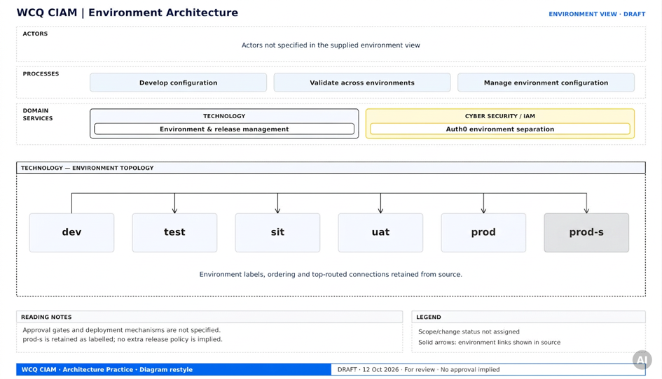
Figure 22 - Environment Promotion Flow

Transition | Approval Required
Development (DEV) → Test (TEST) | Development (DEV) → Test (TEST)
Test (TEST) → System Integration Test (SIT) | Test (TEST) → System Integration Test (SIT)
SIT → User Acceptance Testing (UAT) | SIT → User Acceptance Testing (UAT)
UAT → Production | UAT → Production
Production (PROD) → PROD-SUPPORT | Production (PROD) → PROD-SUPPORT
Table 34 - Environment Architecture Interactions and Flows

  - Environment Architecture Key Design Considerations
Identifies the major considerations that influence environment planning, management and ongoing operation.
Consideration | Design Response
Environment Sizing | Each of the six Auth0 tenant environments (DEV, TEST, SIT, UAT, PROD-SUPPORT, PROD) is sized appropriately within Auth0 SaaS public cloud limits, with PROD leveraging multi-region deployment across AWS Sydney and Melbourne (failover) to support sustained authentication loads up to 100 RPS.
Test Data Management | Non-production tenants (DEV, TEST, SIT, UAT, PROD-SUPPORT) enforce strict data privacy using synthetic test profiles and masked credentials, avoiding real production customer PII in lower environments.
Access Control | Enforces strict Role-Based Access Control (RBAC) and least-privilege scoping across dashboard tenant management and CI/CD pipelines, maintaining clear segregation of duties between non-production and production environments.
Environment Availability | All environments are engineered for high availability (99.99%) across dual AWS availability regions (active, warm standby).
Cost Management | Leverages Auth0 multi-tenant SaaS licensing and Monthly Active User (MAU) billing models, allowing scalable cost allocation across non-production and production tenants without requiring dedicated server infrastructure.
Operational Support | All six Auth0 tenant environments are fully automated and governed via Infrastructure as Code (IaC) using GitHub CI/CD and Terraform, backed by real-time operational log streaming to Datadog for health monitoring and telemetry.
Table 35 - Environment Architecture Key Design Considerations

  - Environment Architecture Checklist
Before completing this section, confirm that:
- Required environments are clearly identified.
- Environment purposes and responsibilities are defined.
- Environment standards and governance controls are documented.
- Promotion and deployment processes are understood.
- Environment dependencies have been identified.
- Security and access requirements are addressed.
- Environment sizing and data management considerations are documented.
- Environment architecture supports delivery, testing and operational objectives.
A reader should be able to understand what environments exist, how they support the solution lifecycle, how releases move between environments, what governance controls apply, and how the environments are managed to support reliable and secure delivery.

- Non-Functional Design
Purpose: Defines the quality attributes, operational expectations and service characteristics required for the solution. This section describes how the solution will meet business and technical expectations for availability, performance, scalability, resilience and ongoing operational support.
[PLACEHOLDER]
Figure 23 - NFR Matrix
  - Availability
Defines the required availability and uptime characteristics of the solution.
Requirement | Target
Service Availability (Auth0) | 99.99%
Service Hours | 24x7
Recovery Time Objective (RTO) | See table below
Recovery Point Objective (RPO) | See table below
Planned Outage Window | None
Table 36 - Availability Requirements

Failure Type | RPO | RTO
Availability Zone Failure | 0 | 0
Regional Failure | 1 minute | 15 minutes
Data Corruption / Restore from Backup | 1 hour | 4 hours

  - Performance
Defines the performance characteristics required by the solution to support business operations and user expectations.
Note: Auth0 SLA does not include API response times for Authentication API and Management API (Reference). A load test may be performed by WorkCover according to the Auth0 Load Testing Policy to gather performance metrics under load.
Requirement | Target
Authentication Response Time | Near real time
Concurrent Users | To be advised by various integrated business portals. Business requirements required.
Transactions per Second | 100 Requests Per Second (RPS) sustained for Authentication API
Peak Processing Window | Support peak seasonal demand
API Response Time | Near real time
Table 37 - Performance Requirements

  - Scalability
Defines how the solution will accommodate future growth, increasing demand and evolving business requirements.
Requirement | Design Approach
User Growth | The Auth0 SaaS platform user store natively scales to support millions of identity profiles without requiring underlying infrastructure re-architecting. Billing is managed via Monthly Active User (MAU) tiers, which can be dynamically upgraded as adoption increases without impacting tenant availability.
Transaction Growth | Horizontal elastic scaling is automatically provided by the Auth0 SaaS platform, operating under the following Enterprise Public Cloud rate limits:  • Authentication API: 100 RPS sustained per tenant  • Management API: 16 RPS sustained (50 RPS Burst) per tenant  Specific endpoint rate limits are governed by Auth0 operational policies.
Seasonal demand | To accommodate expected peak business periods (e.g., policy renewal cycles or marketing campaigns), temporary rate limit uplift add-ons (2X/200 RPS or 3X/300 RPS for 48 hours/month) can be activated to ensure seamless transaction processing without throttling.
New Channels | The standards-based OIDC and OAuth 2.0 architecture natively supports future channel onboarding (such as native mobile applications, single-page applications, and third-party partner portals) without requiring core authentication redesign.
Platform Growth | The platform modularity enables future integration of advanced capabilities (such as identity federation with Queensland Digital Identity - QDI, multi-persona management, and risk-based adaptive MFA) across subsequent project horizons.
Table 38 - Scalability Requirements

  - Resilience and Recoverability
Defines how the solution will tolerate failures, maintain service continuity and recover from incidents.

Requirement | Design Response
Service Failure | AWS Availability Zone Failure: Zero downtime and zero data loss (RPO: 0, RTO: 0) achieved via multi-availability zone deployment within the primary region.  AWS Regional Failure: Automated regional failover from AWS Sydney (primary) to AWS Melbourne (warm standby) delivering an RPO of 1 minute and RTO of 15 minutes.
Data Protection | Automated tenant backups and point-in-time recovery processes targeting an RPO of 1 hour and an RTO of 4 hours. This does not include accidental or malicious data deletion on a particular tenant (environment).
Disaster Recovery | Geo-redundant multi-region architecture deployed across AWS Sydney (primary) and Melbourne (warm standby) supporting 99.99% service availability.
Infrastructure Failure | Critical components remain available during component failures Multi-zone deployment architecture
Business Continuity | Core authentication services and token generation continue uninterrupted during component-level failures and regional degradation events.  Business continuity needs to be designed for each future, integrated application.
Table 39 - Resilience and Recoverability Requirements

  - Operability and Supportability
Defines the operational capabilities required to monitor, manage, support and maintain the solution throughout its lifecycle.

Requirement | Design Response
Monitoring | Real-time operational log streaming from Auth0 to the WCQ Datadog Service for health telemetry, metric aggregation, and platform performance dashboards.
Alerting | Automated security incident triggers routed to Microsoft Sentinel via Azure Event Grid, combined with Datadog threshold alerting for operational errors and rate-limit events.
Support Model | Level 1, 2 and 3 support defined as follows  IAM Operations / technology, level 2 and 3 support2&3)  Service desk will provide level 1 support  In the future state when digital portals are integrated to the CIAM Claims advisor – Future (login issues)
Maintenance | Zero-downtime maintenance provided by fully managed Auth0 SaaS infrastructure, supplemented by automated IaC tenant updates via GitHub Actions/Terraform.
Logging | Comprehensive application and infrastructure logging
Operational Visibility | Dual-stream logging architecture delivering 30-day native Auth0 audit retention alongside real-time SIEM audit streaming into Microsoft Sentinel.
Table 40 - Operability and Supportability Requirements

  - Non-Functional Design Checklist
Before completing this section, confirm that:
- Availability targets are clearly defined.
- Performance requirements are measurable.
- Scalability expectations support future growth.
- Resilience and recovery requirements are documented.
- Operational support requirements are understood.
- Service levels align with business expectations.
- Monitoring and alerting requirements are defined.
- Non-functional requirements can be validated through testing.
A reader should be able to understand how well the solution must perform, how available it must be, how it will scale, how it will recover from failures, and how it will be operated and supported throughout its lifecycle.

- RAID Assessment
  - Architecture Decisions
Purpose
Documents the significant architecture decisions that shape the solution's direction, design, delivery, operation and future evolution. This section provides traceability for key architectural choices, explains their rationale and impacts, identifies associated trade-offs, and highlights dependencies on other decisions, approvals or governance outcomes.

Guidance for Solution Architects
Focus on decisions that materially influence business outcomes, architecture direction, security posture, operating model, delivery approach, cost profile or future extensibility. Decisions should be traceable to business drivers, requirements, principles and architecture objectives.
Where Architecture Decision Records (ADRs) exist, this section should provide a summary and cross-reference the detailed record. Significant trade-offs should be documented transparently to ensure stakeholders understand both the benefits gained and the constraints accepted through each decision.

Example
Architecture Decision Register
Decision ID | Decision Summary | Owner | Status | Approval Authority | ADR Reference
ADR-001 | Adopt the Customer Identity Platform Auth0 as the strategic customer authentication solution. | Solution Architect |  | Architecture Design Authority | ADR-001
ADR-002 | Use API-based integration for external system interactions. | Integration Architect |  | Architecture Design Authority | ADR-002
ADR-003 | Adopt an Auth0 AU Public Cloud deployment model. | Technology Architect |  | Strategic Architecture Forum | ADR-003
ADR-004 | Prefer configuration over custom development where platform capabilities exist. | Solution Architect |  | Architecture Design Authority | ADR-004
ADR-005 | Minimize the storage of End-User PII on Auth0 to what is technically necessary. | Solution Architect |  | Architecture Design Authority | ADR-005
ADR-006 | Use mock components for OIDC Provider, Web Portal, Business API, SMS Provider and Email Provider for Horizon 1 implementation. | Solution Architect |  | Architecture Design Authority | ADR-006
ADR-007 | No user profile and credential migration in scope for Horizon 1 | Solution Architect |  | Architecture Design Authority | ADR-007
Table 21 - Architecture Decision Register
Decision Impacts and Trade-Offs
Decision | Benefits | Trade-Offs / Consequences
Use of managed SaaS CIAM platform (Auth0) | Improved scalability, resilience and deployment agility, low maintainability and risk and low effort. | Non-SaaS CIAM solutions (inhouse developed or on-prem deployed or cloud-hosted) are high effort and high risk and high maintenance.
Strategic identity platform | Reduced duplication, simplified support, centralized configuration and control, standard protocols and stronger governance. | Siloed identity stores (v/s strategic, central platform) result in multiple identity profiles and credentials to secure and maintain and lack single sign-on.
API-based integration | Improved interoperability, reuse and standardisation. | Requires API platform capability and integration maturity.
Configuration before customisation | Simplifies upgrades and reduces ongoing maintenance effort. | May require business process changes to align with product capabilities.
Use mock components for OIDC Provider, Web Portal, Business API, SMS Provider and Email Provider for Horizon 1 implementation. | Rapid showcasing and implementation of Horizon 1 while still using all design and configuration of a real implementation. This is because all integrations are based on standard protocols like OIDC. | Availability of real components (e.g. web portal, business API etc.) will delay this stage of the project without adding much benefit. (Mock components can be swapped out for real ones at a later time because all integrations are based on standard protocols like OIDC).
Table 22 - Decision Impacts and Trade-Offs
Decision Relationships and Dependencies
Decision ID | Related Decision | Relationship
Table 23 - Decision Relationships and Dependencies

Example Narrative
The Customer Identity and Access Management (CIAM) initiative is guided by several significant architecture decisions intended to improve customer experience, simplify operations and align with enterprise technology strategy.
The primary decision is the adoption of the Enterprise Identity Platform as the strategic identity capability for customer authentication and lifecycle management. This decision enables consolidation of fragmented identity services, strengthens security controls and supports future digital initiatives. Supporting decisions include adoption of API-first integration patterns, a cloud-hosted deployment model and a configuration-first implementation approach.
These decisions provide substantial business and technology benefits but introduce trade-offs relating to migration complexity, platform dependency and operational readiness requirements. Decision dependencies have been identified and are governed through the Architecture Design Authority to ensure alignment with enterprise standards, minimise architectural risk and maintain traceability throughout the solution lifecycle.
This section should provide stakeholders with a clear understanding of the architectural choices shaping the solution, the rationale for those choices and the consequences of alternative approaches not being pursued.

  - Risks & Mitigation Actions
Purpose
Identifies risks that may impact the successful delivery, operation, security, performance or expected outcomes of the proposed solution and defines the actions required to mitigate, manage or monitor those risks.

Guidance for Solution Architects
Document risks that could materially affect business outcomes, solution viability, delivery timelines, operational performance or compliance obligations. Risks should be concrete, measurable and actionable. Focus on architecture-significant risks such as platform readiness, integration complexity, migration challenges, security concerns and external dependencies.
Mitigation actions should be practical, time-bound and assigned to an accountable owner. Significant risks should align with project governance and architecture review processes.

Example
Risk ID | Risk Description | Impact | Likelihood | Owner | Mitigation
R001 | Vendor resources may not be available when required | Medium | Medium | Delivery Manager | Confirm resource commitments through contractual arrangements
R002 | Availability of CI/CD platform and source control repository may delay the build stages of the project. | Medium | Low | Delivery Manager | Confirm the right team is engaged from the very beginning and provide enough advanced notice.
R003 | Real OIDC Provider (e.g. QDI i.e. Queensland Digital Identity) may delay the project delivery | Medium | Medium | Delivery Manager | Mock OIDC Provider will be used for the build. QDI OIDC Provider will be an additional integration.
R004 | Building 6 environments may introduce delays during the build phase | Medium | Low | Delivery Manager | The environment configurations will be identical as much as possible and the build will be via CI/CD and terraform automation.
Table 24 - Project Risk Register and Mitigation Plan

  - Assumptions & Constraints
Purpose
Documents the assumptions underpinning the proposed solution and the constraints that influence architecture decisions, delivery planning and solution implementation.
Guidance for Solution Architects
Capture assumptions that materially influence architecture decisions, scope, effort, sequencing or expected outcomes. Assumptions should be reviewed periodically and validated as the initiative progresses.
Constraints should represent conditions that are mandatory, non-negotiable or outside the control of the initiative. These often include enterprise standards, regulatory obligations, approved platforms, budget limitations and delivery timelines.
Avoid using assumptions as undocumented requirements.

Example
Assumptions
ID | Category | Assumption
A001 | Business | Business representatives will be available throughout design and testing activities
A002 | Technology | Strategic enterprise platforms will remain available during implementation
A003 | Technology | Participating external applications and mock components will natively support standard OAuth 2.0 and OpenID Connect (OIDC) protocols.
A004 | Delivery | Operational resources for IAM platform administration and deployment automation via GitHub Actions/Terraform will be available throughout all project phases.
A005 | Delivery | Funding approval remains in place for all planned phases
Table 25 - Project Assumptions Register
Constraints
ID | Category | Constraint
C001
C002 | Technology | Must utilise approved strategic enterprise platforms
C003 | Technology | Tenant configurations and traffic volumes must operate within established Auth0 Enterprise Public Cloud rate limits (e.g., 100 RPS sustained for the Authentication API).
C004 | Regulatory | Personal Identifiable Information (PII) stored within the CIAM platform must be strictly minimized to email address and phone number (this is not an Auth0 platform technical constraint)
Table 26 - Project Constraints Register

  - Issues & Open Questions
Purpose
Records known issues, unresolved questions and decision points that require investigation, clarification, review or governance approval.
Describe
- Existing problems affecting delivery or design.
- Current blockers and impediments.
- Missing information requiring validation.
- Outstanding architecture and design decisions.
- Questions requiring stakeholder input.
- Governance actions required to achieve resolution.
Include
- Item identifier.
- Item type.
- Description.
- Impact.
- Owner.
- Resolution approach.
- Target date.
- Status.
- Related risk, dependency or decision.

Guidance for Solution Architects
Focus on matters that could delay delivery, prevent approval, compromise architecture quality or create uncertainty in decision-making. Issues and questions should be actively managed and regularly reviewed through project and architecture governance forums.
Provide enough information for decision makers to understand the impact of non-resolution and what action is required.

Example
Item ID | Type | Issue / Open Question | Owner | Target Date | Status
I001 | Issue | Data ownership responsibilities remain unresolved | Business Owner | 15-Sep-2026 | Open
I002 | Issue | Security standard approval pending | Security Lead | 30-Sep-2026 | In Progress
Q001 | Open Question | Which identity verification provider will be selected? | Solution Architect | 30-Sep-2026 | Under Assessment
Table 27 - Issues and Open Questions Register
  - Dependencies
Purpose
Defines accountability for business and solution capabilities and identifies the dependencies that may influence delivery, operation and achievement of target-state outcomes.

Guidance for Solution Architects
Identify dependencies that are outside the initiative's direct control and may influence architecture outcomes, delivery schedules, operational readiness or business value realisation.
Where practical, link dependencies to affected capabilities, roadmap milestones, risks and governance forums. Ownership should clearly identify who is accountable for the business outcome and who is responsible for the enabling technology.
Focus on dependencies with genuine delivery, operational or architectural significance.

Capability Ownership
Capability | Business Owner | Technology Owner | Key Dependency
Customer Identity Management | Head of Customer Services | Customer Platforms Manager | Customer Profile Management
Authentication Management | Digital Channels Manager | Security Platform Owner | Security Monitoring Services
Access Management | Enterprise Security Manager | IAM Platform Owner | Identity Governance Services
Table 28 - Capability Ownership Matrix
Dependency Register
Dependency ID | Dependency Description | Owner | Required By | Impact if delayed
D001 | Hosting platform for and availability of Mock Web Portal Application for all build environments. | Delivery Manager | Build Phase / Testing | Build phase delays
D002 | Hosting platform for and availability of Mock Business API for all build environments. | Delivery Manager | Build Phase / Testing | Build phase delays
D003 | Hosting platform and availability of Mock OIDC Provider for all build environments. | Delivery Manager | Build Phase / Integration | Build phase delays
Table 29 - Project Dependency Register

- Document Control
  - Document Information
Purpose: Records the identifying and administrative information for the document.
ITEM | DETAILS | DESCRIPTION
DOCUMENT TITLE | CIAM Platform Deployment High Level design | The official name of the document.
DOCUMENT NO |  | Unique document number
STATUS | DRAFT | Draft | Final | Approved
VERSION | 0.1 | Version number
AUTHOR | Jatin Vaidya, Versent | The person who wrote the document.
AUTHOR ROLE | Solution Architect | The role title of the author.
CONTRIBUTORS | Mehran Farshadmehr, Versent  Mark Trory-Davies, Senior Identity Specialist | Names of content contributors
TEAM / PROJECT | CIAM | Document produced for team/project.
Table 50 - Document Status Overview

  - Revision History
Purpose: Provides an auditable history of document changes throughout its lifecycle.
VERSION | DESCRIPTION | AUTHOR/S | DATE
V0.1, V0.2 | initial draft | Jatin Vaidya | 12/10/2026
V1.0 | Update to new template (DRAFT) | Mark Trory-Davies | 21/10/2026
Table 51 - Document Revision History

  - Review & Approval
Purpose: Records reviewers, approvers and formal sign-off status.
ROLE | REVIEWER NAME | STATUS | DATE
Data Architect
Enterprise Architect
Security Architect
Solution Architect
Integration Architect
Security Consultant
Integrated Design
Project Team
Business Sponsor
Table 52 - Document Review & Endorsement Status

  - References
Purpose: Lists related documents, standards, policies and supporting materials referenced by this document.
DOCUMENT | LINK
Table 53 - References

  - Architecture Repository References
Purpose: Identifies related architecture artefacts, standards, patterns, decisions and reference materials stored within the architecture repository that support, inform or govern this document.
DOCUMENT | LINK
Table 54 - Architecture Repository References

  - Document Submission Status
AWG | OUTCOME | Proceed | Do Not Proceed to ADA
AWG | DATE | DD Month YYYY
AWG | CONDITIONS
ADA | OUTCOME | Challenge | Advise | Refer | Escalate | Noted (default)
ADA | DATE | DD Month YYYY
ADA | CONDITIONS
SAF | OUTCOME | Challenge | Advise | Refer | Escalate | Noted (default)
SAF | DATE | DD Month YYYY
SAF | CONDITIONS
Table 55 – Document Submission Status – Document Name

  - Document Approval
APPROVER | SIGNATURE
APPROVER | NAME
APPROVER | ROLE
APPROVER | DATE
Table 56 – Document Approval – Document Name
- Architecture Reference Material
  - Glossary of Acronyms & Terms
Defines terminology and abbreviations used within the document. The table can be found in the Architecture Reference Manual. 0x - Architecture Reference Manual - ARM - v0.0.1 (DRAFT).docx

  - Architecture Model & Diagram Definitions
This provides a standard definition for every architecture model, diagram, matrix and visual artefact referenced throughout the architecture document set. The table can be found in the Architecture Reference Manual. 0x - Architecture Reference Manual - ARM - v0.0.1 (DRAFT).docx
- Appendix

